

Sri Lanka Institute of Information Technology

**Collaborative** **Shopping Platform Using Restful Services**

**And**

**WSO2 Enterprise Integrator**

**Project Report**

Distributed System Assignment 02

Submitted by:

IT15000118 – (L.L.C.T. Alwis)

Submitted to:

………………………………

Dr. Dharshana Kasthurirathna

**Group members**

|  |  |
| --- | --- |
| Student ID | Name |
| IT19133850 | Yasas R.M. |
| IT19152288 | Bandara M.H.M.N.D.T. |
| IT19215884 | Gunawardana K.H.R |
| IT19056258 | Dhanasekara D.M.S.M |

**Group Contribution**

|  |  |
| --- | --- |
| Student ID | Implementations |
| IT19133850 | 1. Product service to search (Full text), filter and perform all crud operations. 2. Shopping cart management. 3. Dummy credit card payment gateway service. 4. Dummy mobile payment gateway service using Twilio. 5. Place orders with multiple products. 6. Track orders. 7. Using WSO2 EI (Enterprise Integration – ESB) to integrate services at the backend and expose a common web API. 8. Route the payment to either the banking payment gateway or the mobile operator, based on some parameter of the payment request message. |
| IT19152288 | 1. Seller service where sellers can add/update/delete items. |
| IT19215884 | 1. JWT authentication service to perform role based authentication. |
| IT19056258 | 1. Delivery service to deliver orders. |

Contents

1. High Level Architectural Diagram of the System 5

2. Service Interfaces exposed by each service 6

2.1. Authentication service 6

2.2. Seller service 6

2.3. Buyer service 6

2.4. Credit card payment gateway service 6

2.5. Mobile payment gateway service 6

2.6. Delivery service 6

3. Workflows explained with code Snippets 7

3.1. Process of validating the token 7

3.2. Process of searching the products 8

3.3. Shopping cart management 9

3.3.1. Add a product to shopping cart 10

3.3.2. Update products quantity in shopping cart 13

3.3.3. Retrieve user’s shopping cart 14

3.4. Order management 15

3.4.1. Process of creating a new order 16

3.4.2. Process of Saving / Updating buyer details and delivery in order 20

3.4.3. Process of retrieving order details 24

3.5. Processing payments 25

3.5.1. Process of payment through credit card 27

3.5.2. Process of payment through mobile payment gateway 30

3.5.3. Process of requesting mobile pin number 33

3.5.4. Process of listening to payment notifications 36

3.5.5. Process of placing cash on delivery order. 43

4. Authentication and Security Mechanism adopted with system 45

5. Screenshots of the User Interfaces 46

6. Appendix 47

6.1. WSO2 Enterprise Integrator 47

6.1.1. Authentication service 47

6.1.2. Seller service 47

6.1.3. Buyer service 47

6.1.4. Credit card payment gateway service 47

6.1.5. Mobile payment gateway service 47

6.1.6. Delivery service 47

6.2. Rest Services 48

6.2.1. Authentication service 48

6.2.2. Seller service 48

6.2.3. Buyer service 48

6.2.4. Credit card payment gateway service 48

6.2.5. Mobile payment gateway service 48

6.2.6. Delivery service 48

# High Level Architectural Diagram of the System

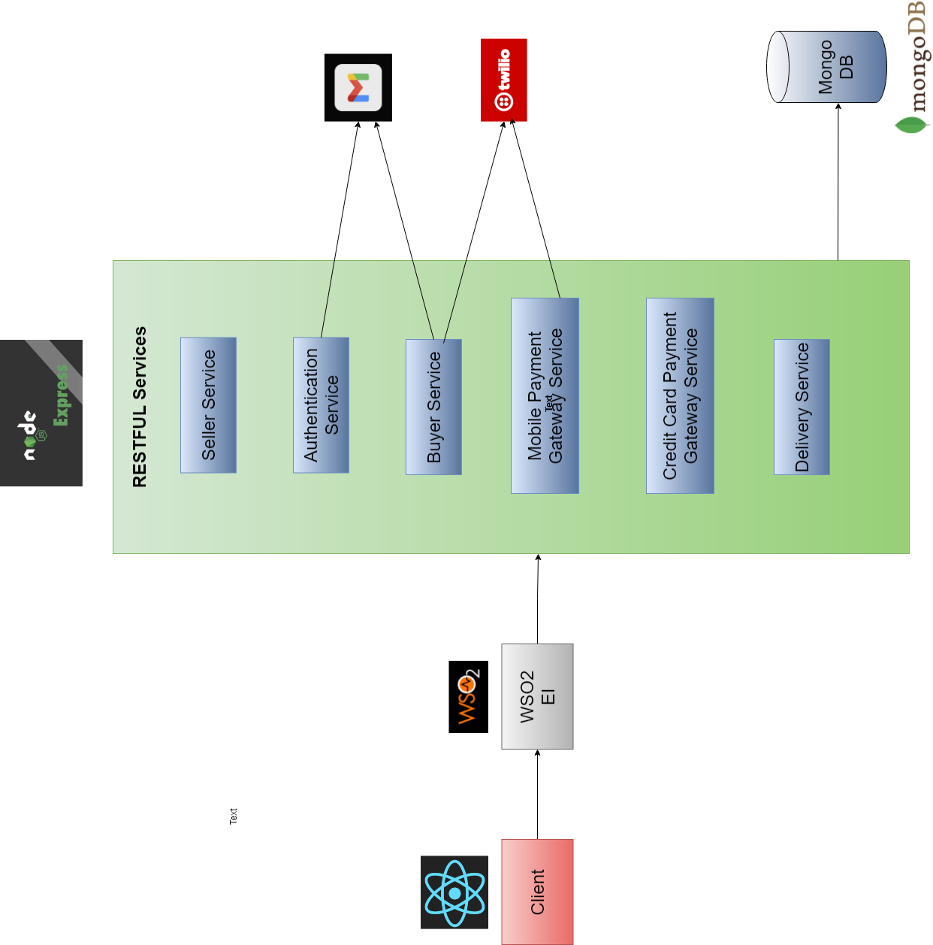

# Service Interfaces exposed by each service

## Authentication service

## Seller service

## Buyer service

## Credit card payment gateway service

## Mobile payment gateway service

## Delivery service

# Workflows explained with code Snippets

## Process of validating the token

Service interface

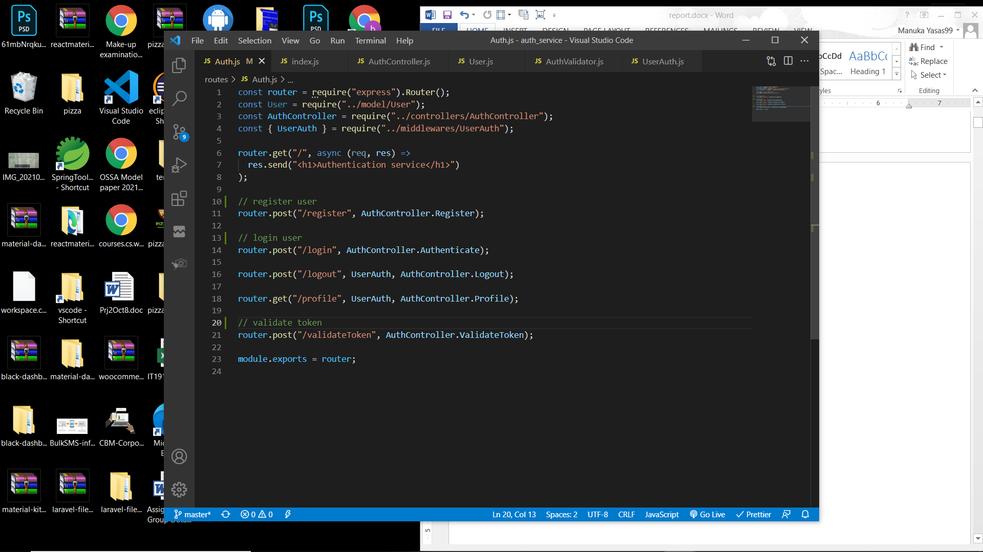

Service function

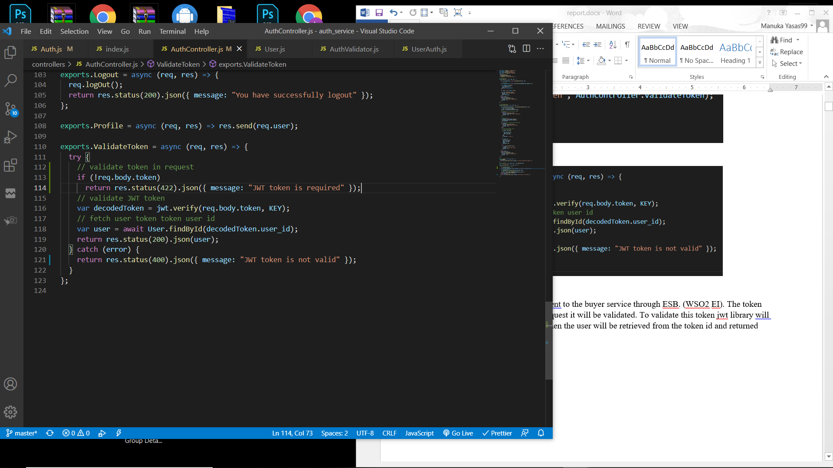

The initial POST request will be sent to the auth service through ESB. (WSO2 EI). The token will be sent as a property in the request and it will be validated. If the token is not present then an error response with status code 422 will be returned.

To validate this token jwt library will be used. If the token is validated then the user will be retrieved from the token id and returned back. Else, an error response with status code 400 will be returned.

## Process of searching the products

Service interface

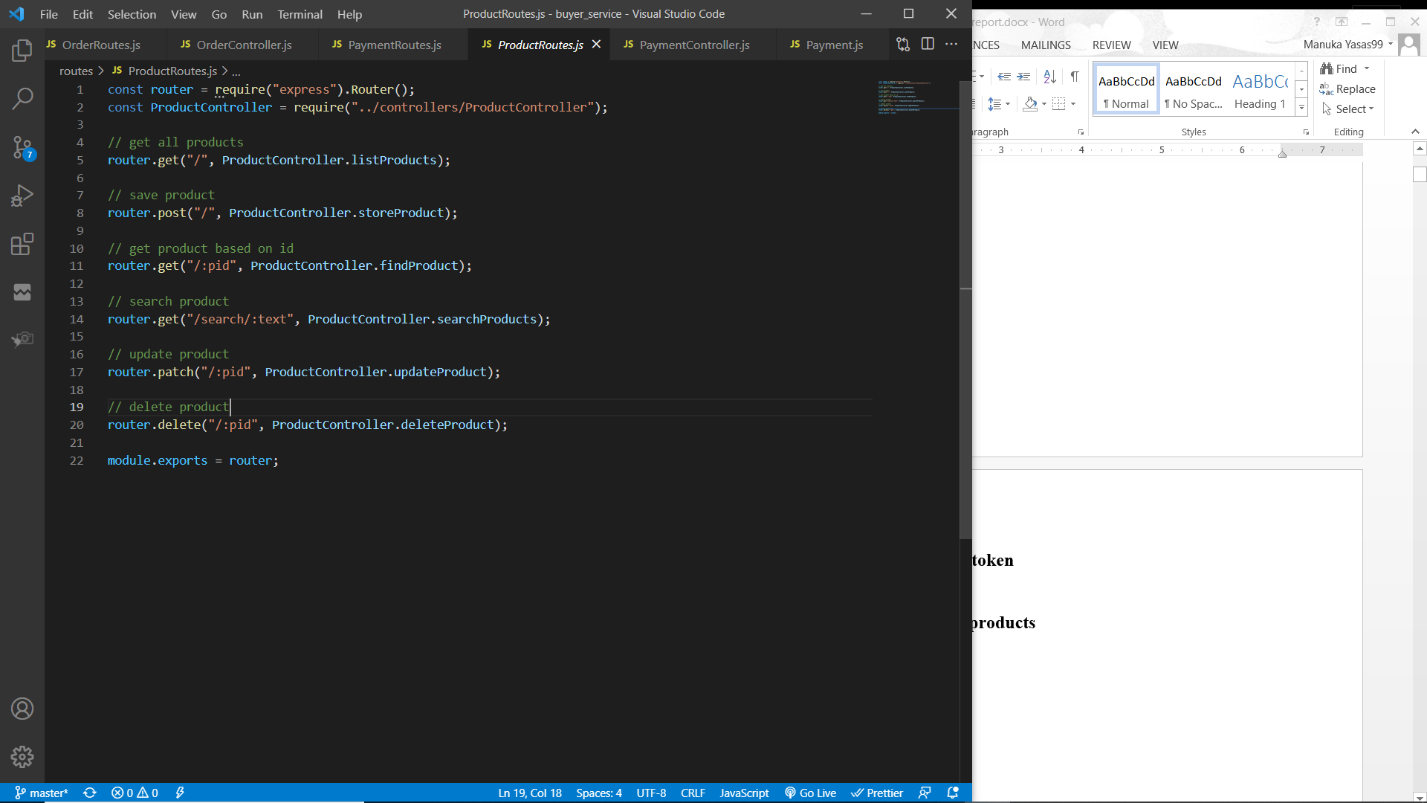

Service function

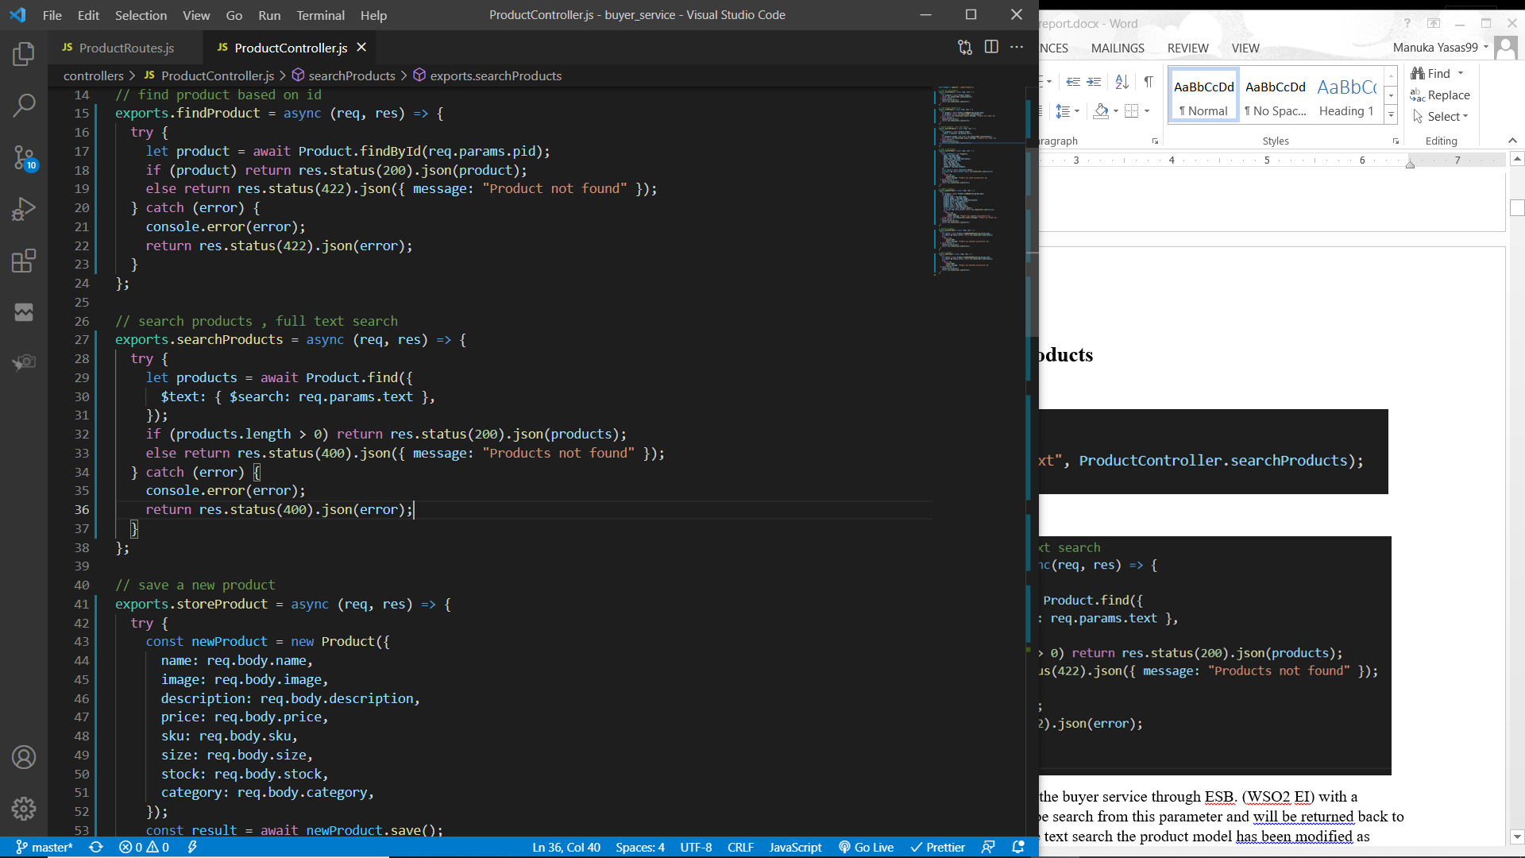

The initial GET request will be sent to the buyer service through ESB. (WSO2 EI) with a parameter (search text). Products will be search from this parameter and will be returned back to the client through ESB. To perform the text search the product model has been modified as below.

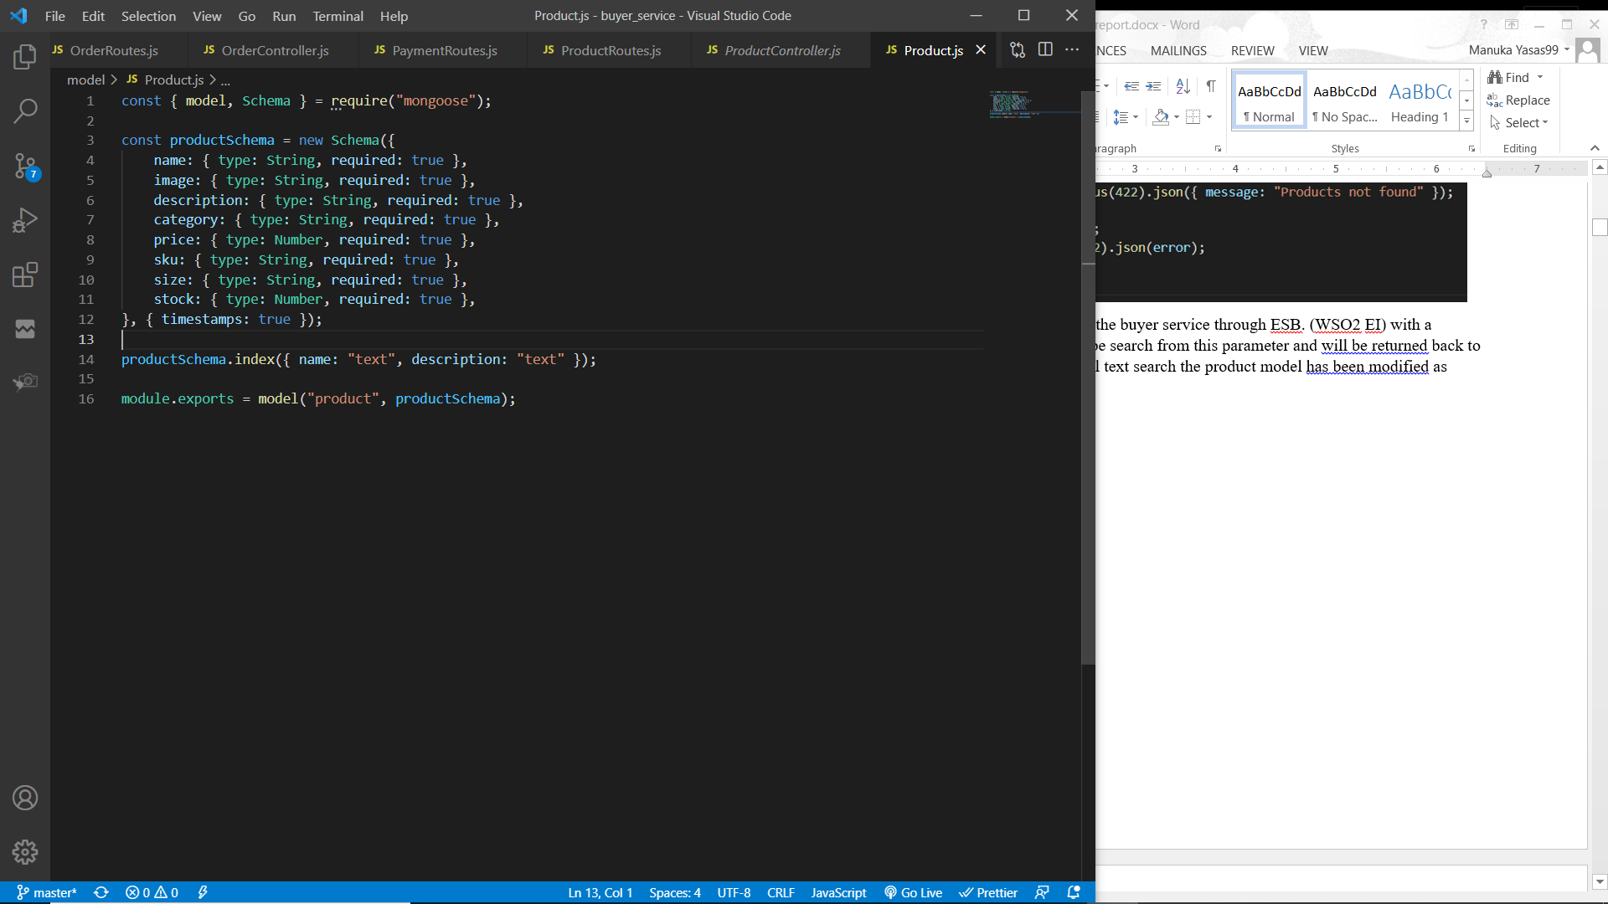

When searching products, it will match the text with product names and descriptions. If no products were found an error response with status code 400 will be sent back.

## Shopping cart management

Service functions / interfaces to manage the shopping cart.

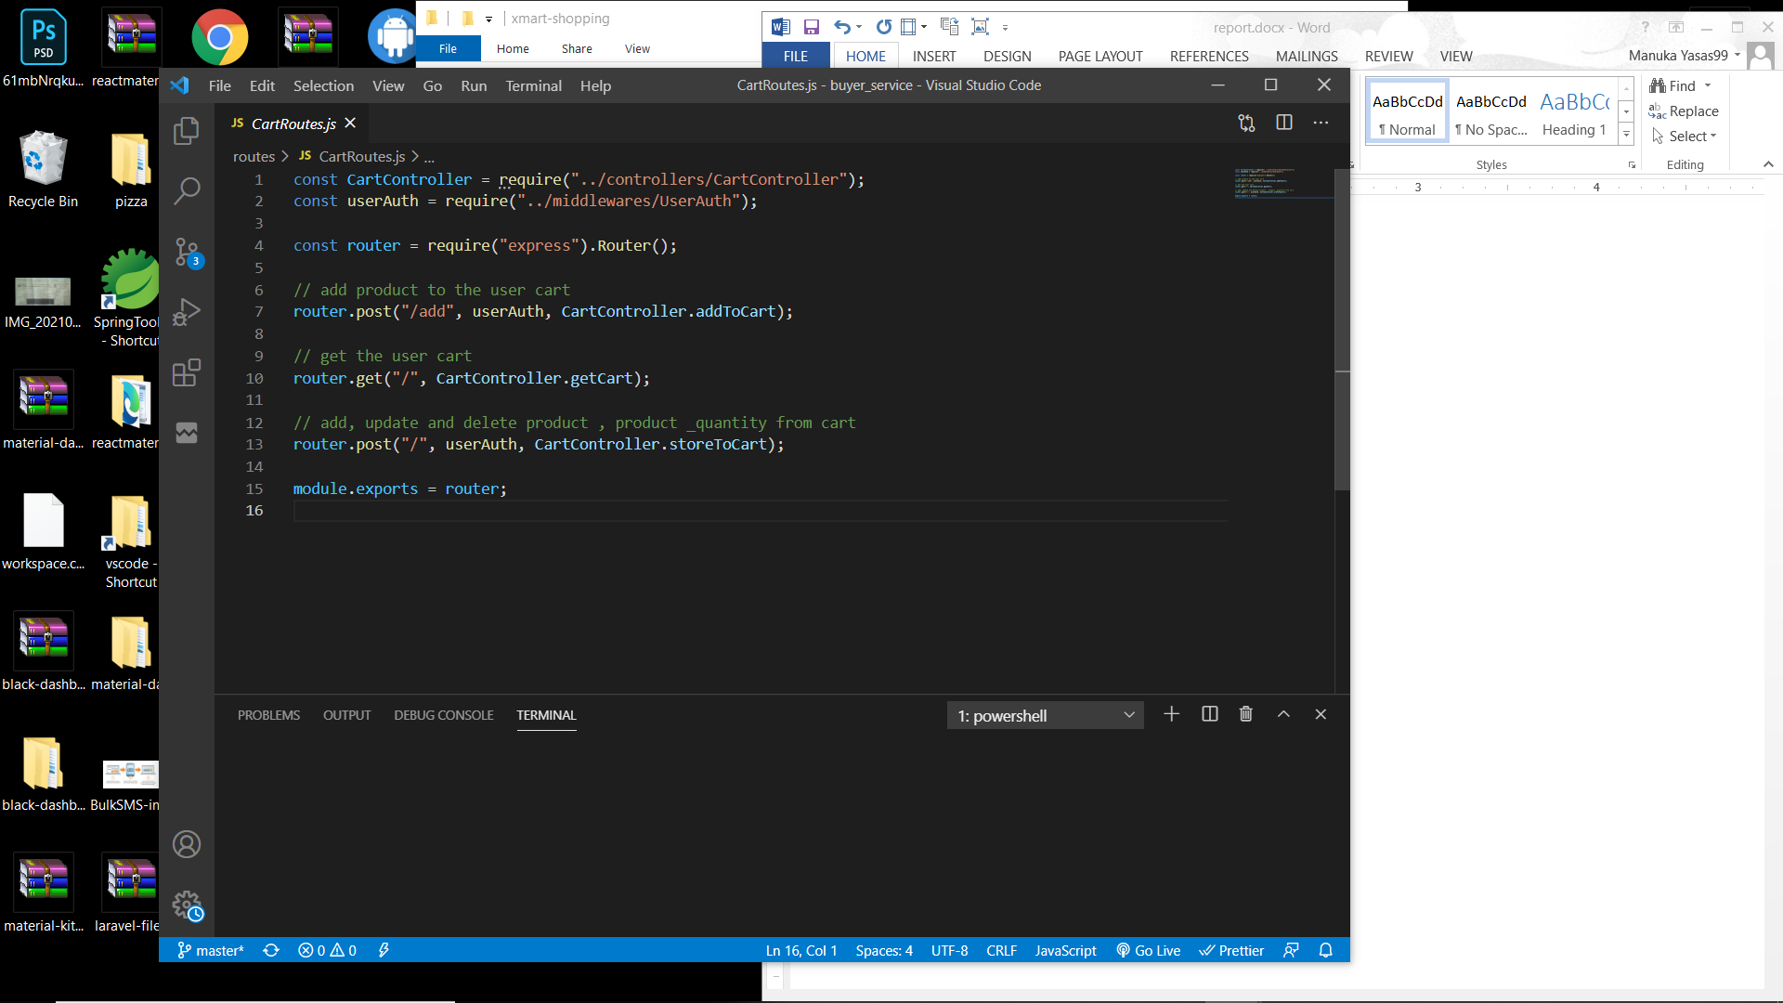

There are three routes in cart management in the buyer service.

1. A POST request with product and its quantity to add a product to shopping cart.
2. A GET request to retrieve user’s cart details with products.
3. A POST request to save / update product quantities in the shopping cart.

All these routes are mapped using the WSO2 Enterprise Integrator.

### Add a product to shopping cart

Service function to add a product to cart

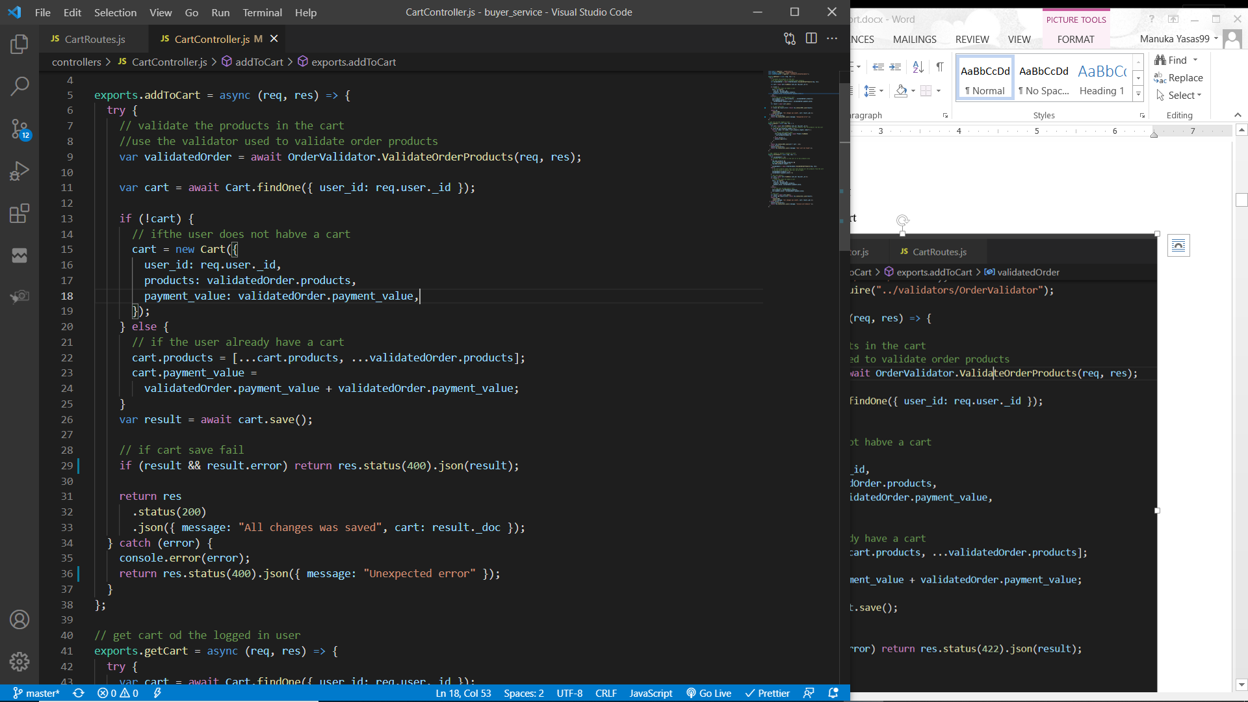

Validator function to validate request body such as valid products, products have stock (validateOrderProducts)

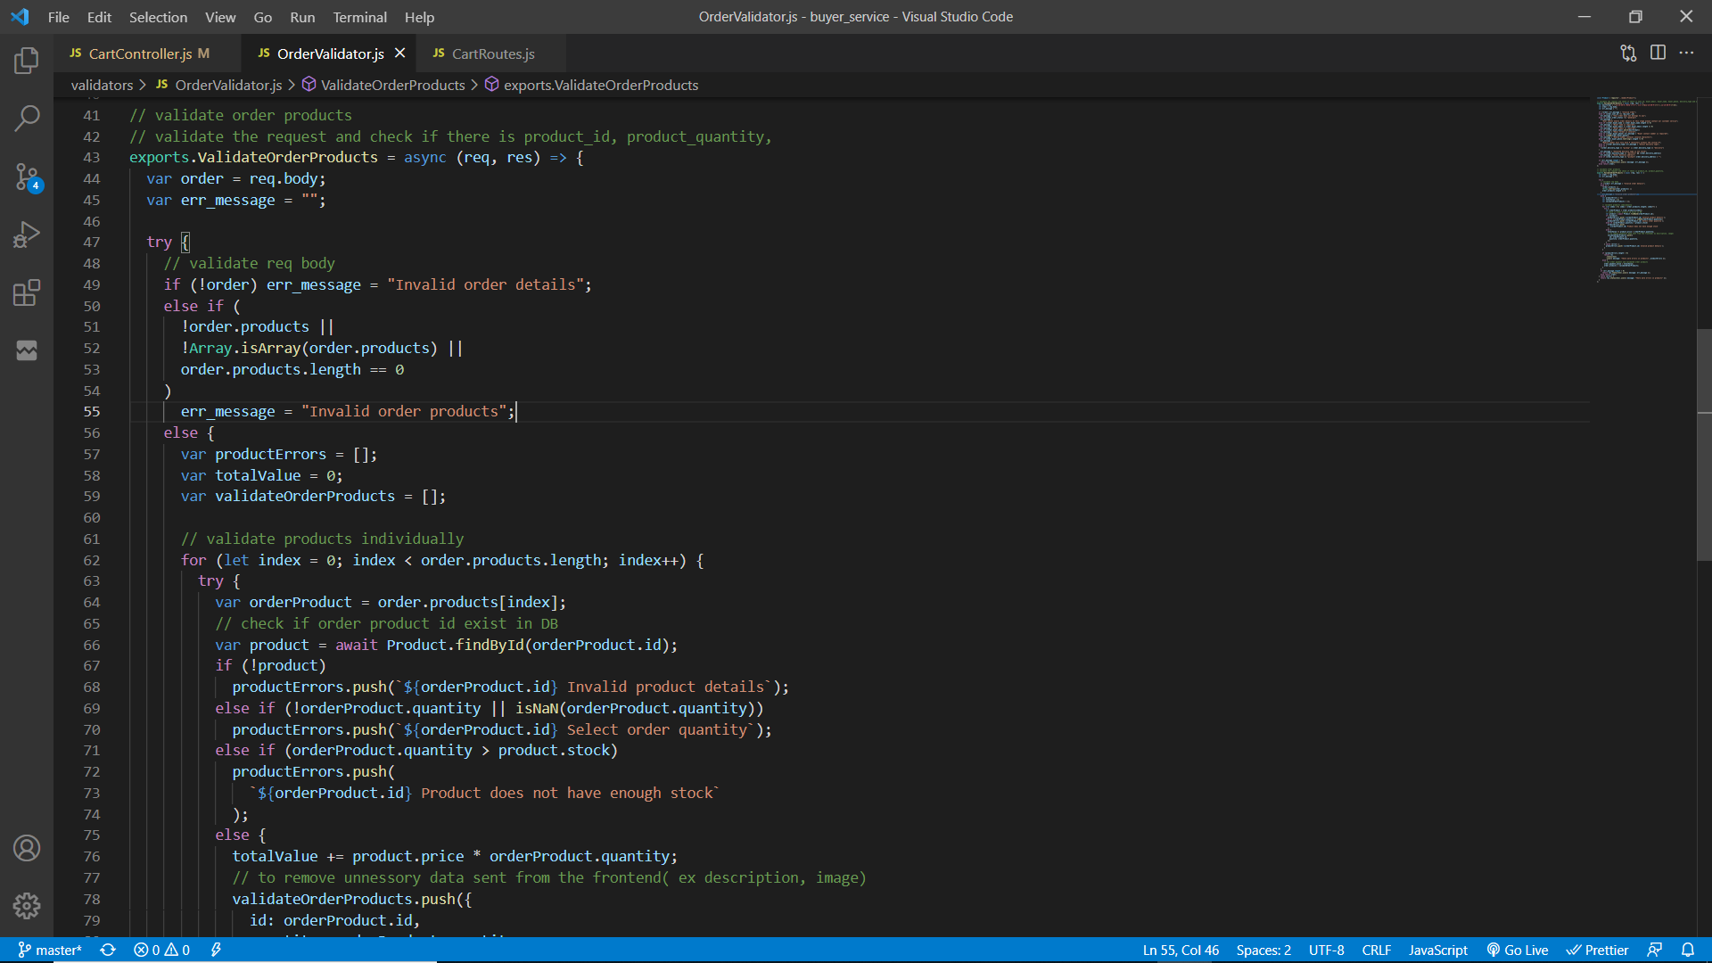

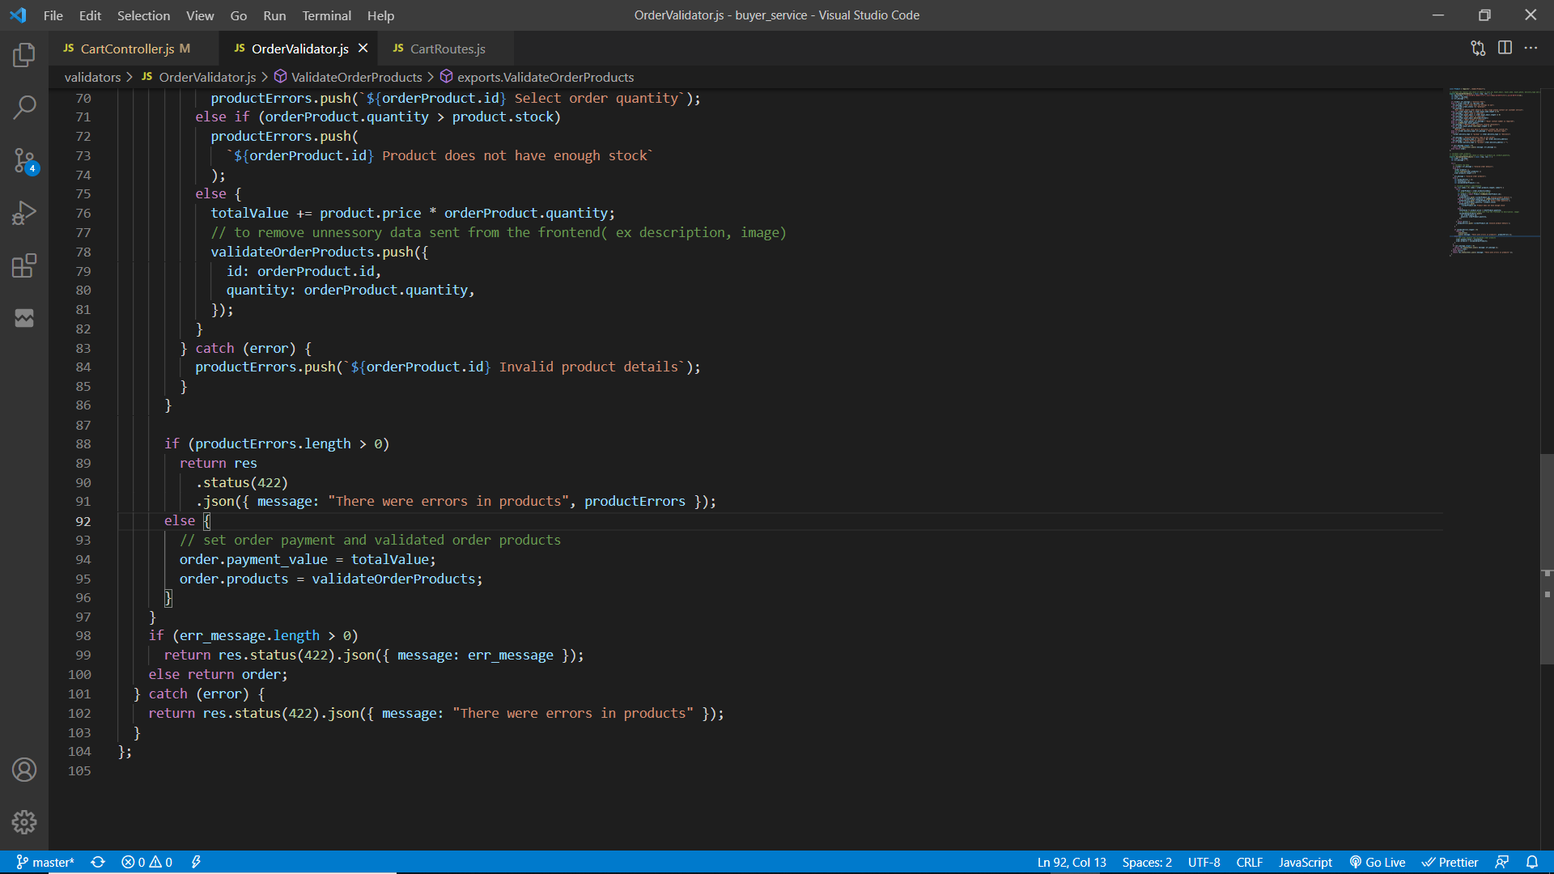

The initial POST request will be sent to the buyer service through ESB. (WSO2 EI).

To add a product to cart, user must be authenticated for this “userAuth” middleware is used to filter the request and allow only authenticated users. Request body must have product id and its quantity. Then the request is validated to check if it contains product data that exist in database also the product quantity requested is less than or equal with its stock else relevant error messages are sent back to the client through ESB. If the request body is validated, it will return the total cart value(value of products * quantity) with the products.

Then user cart will be retrieved from the database using the user’s id. If the cart does not exist, create a new cart by providing user’s ID, products and the total cart value. Else, update the existing cart by adding the new product to cart products and the total cart value.

The cart will be saved/updated and if it fails then an error message will be sent else, the updated user cart object will be sent to the client through ESB.

### Update products quantity in shopping cart

Service function

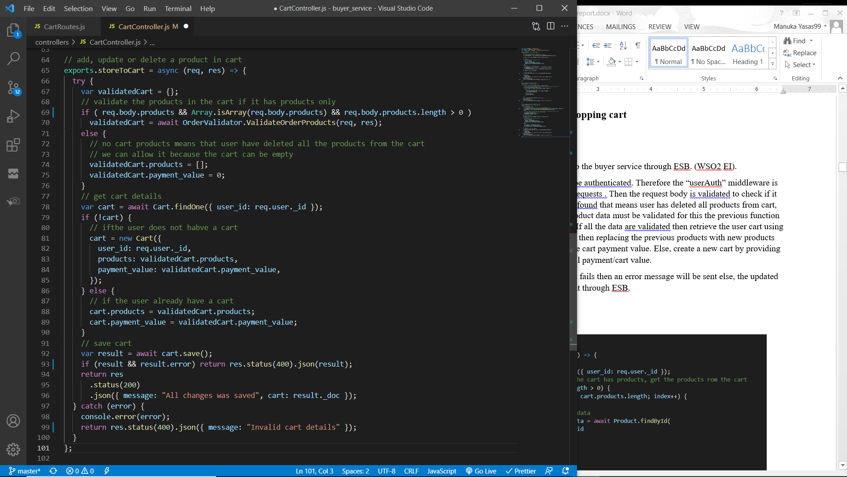

The initial POST request will be sent to the buyer service through ESB. (WSO2 EI).

To update product quantity user must be authenticated. Therefore the “userAuth” middleware is used to filter the authenticated users / requests . Then the request body is validated to check if it contains products. If no products were found that means user has deleted all products from cart, but if products are found then these product data must be validated for this the previous function “validateOrderProducts” will be used. If all the data are validated then retrieve the user cart using the user’s ID and then if there is a cart, then replace previous products with new products along with their quantity and update the cart payment value. Else, create a new cart by providing user’s id, products data and the total payment/cart value.

The cart will be saved/updated and if it fails then an error message will be sent else, the updated user cart object will be sent to the client through ESB.

### Retrieve user’s shopping cart

Service function

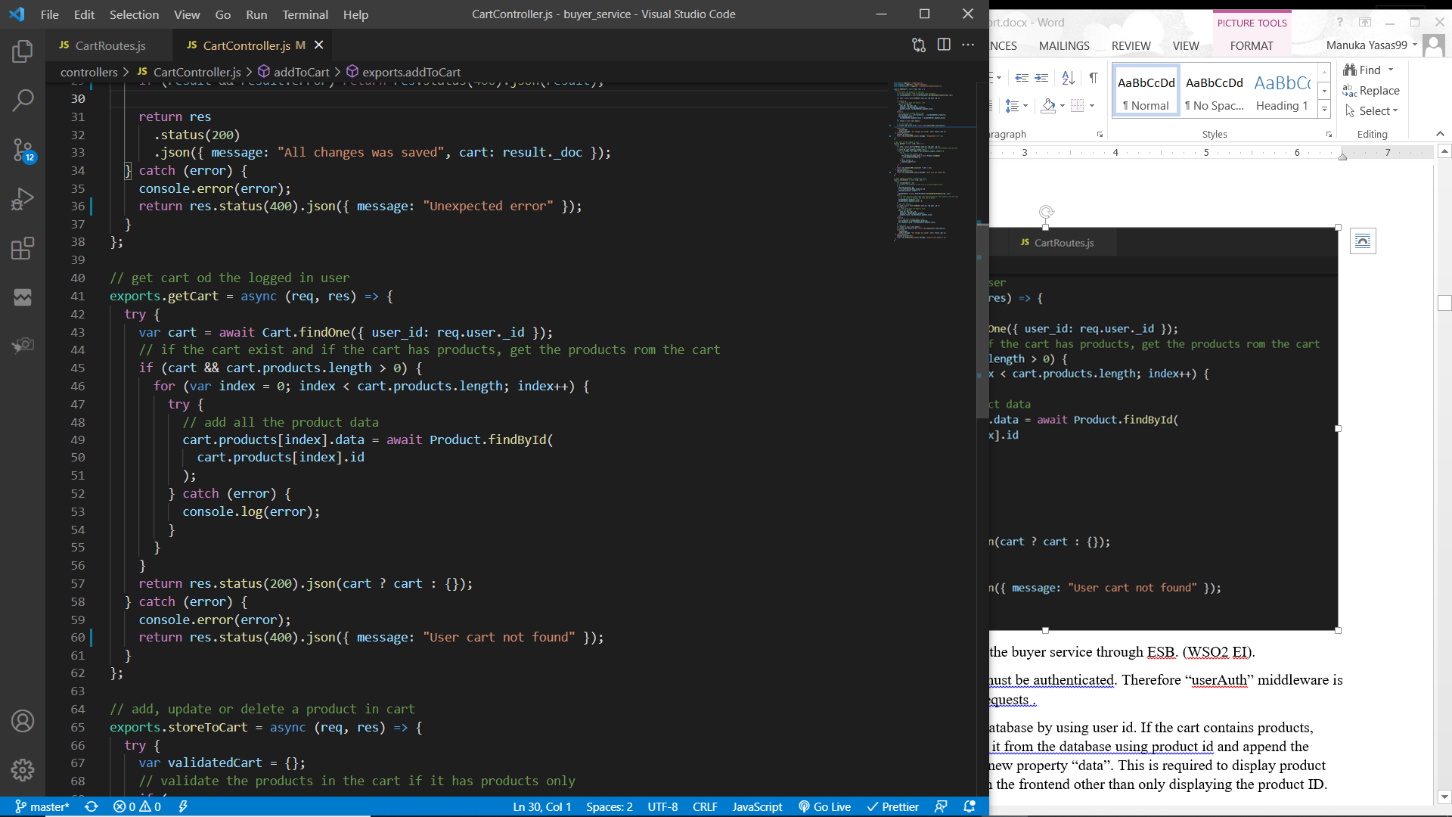

The initial GET request will be sent to the buyer service through ESB. (WSO2 EI).

To retrieve user’s shopping cart, user must be authenticated. Therefore “userAuth” middleware is used to filter the authenticated users/ requests .

User’s cart will be retrieved from the database by using user id. If the cart contains products, loop through each product and retrieve it from the database using product id and append the product data to the cart product with a new property “data”. This is required to display product image, category, price and other data in the frontend other than only displaying the product ID.

Return the new cart with all product data and if there is no cart found then return an empty object via ESB to the client.

## Order management

Service functions / interfaces to manage orders.

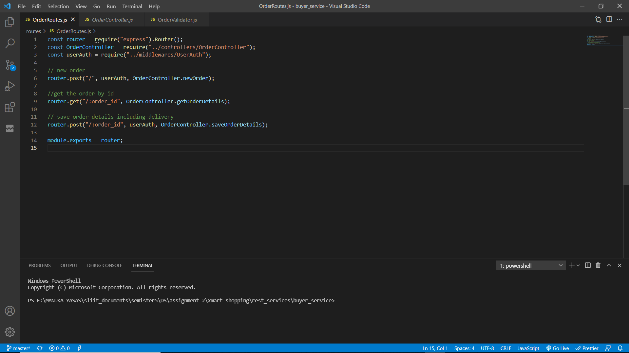

There are three routes to manage orders.

1. A POST request to create a new order with products and its quantities.
2. A GET request to retrieve an order by the order ID sent as a parameter in the request.
3. A POST request to save / update the order buyer details and delivery information.

All these routes are mapped using the WSO2 Enterprise Integrator.

To place an order there are few steps. Initially products with their quantity will be sent to the buyer service and then it will save it and return an object with the payment value and a unique order id. User will navigate to save buyer information and delivery information through the order id. After saving the above details user will navigate for the payments. Payments can be made through cash on delivery, credit / debit card (dummy service) or though mobile service provider (dummy service). After a successful payment user will get and email (through Gmail) and a SMS (though Twillio).

### Process of creating a new order

Workflow diagram

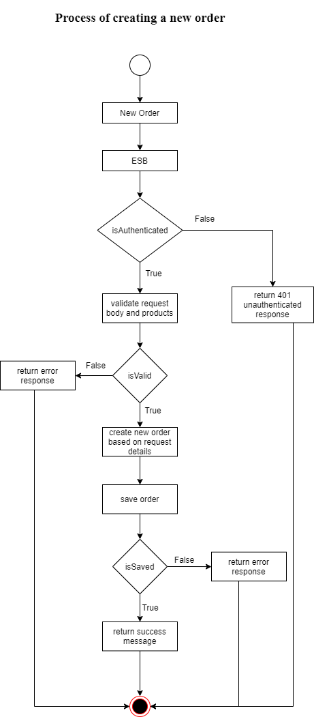

Service function

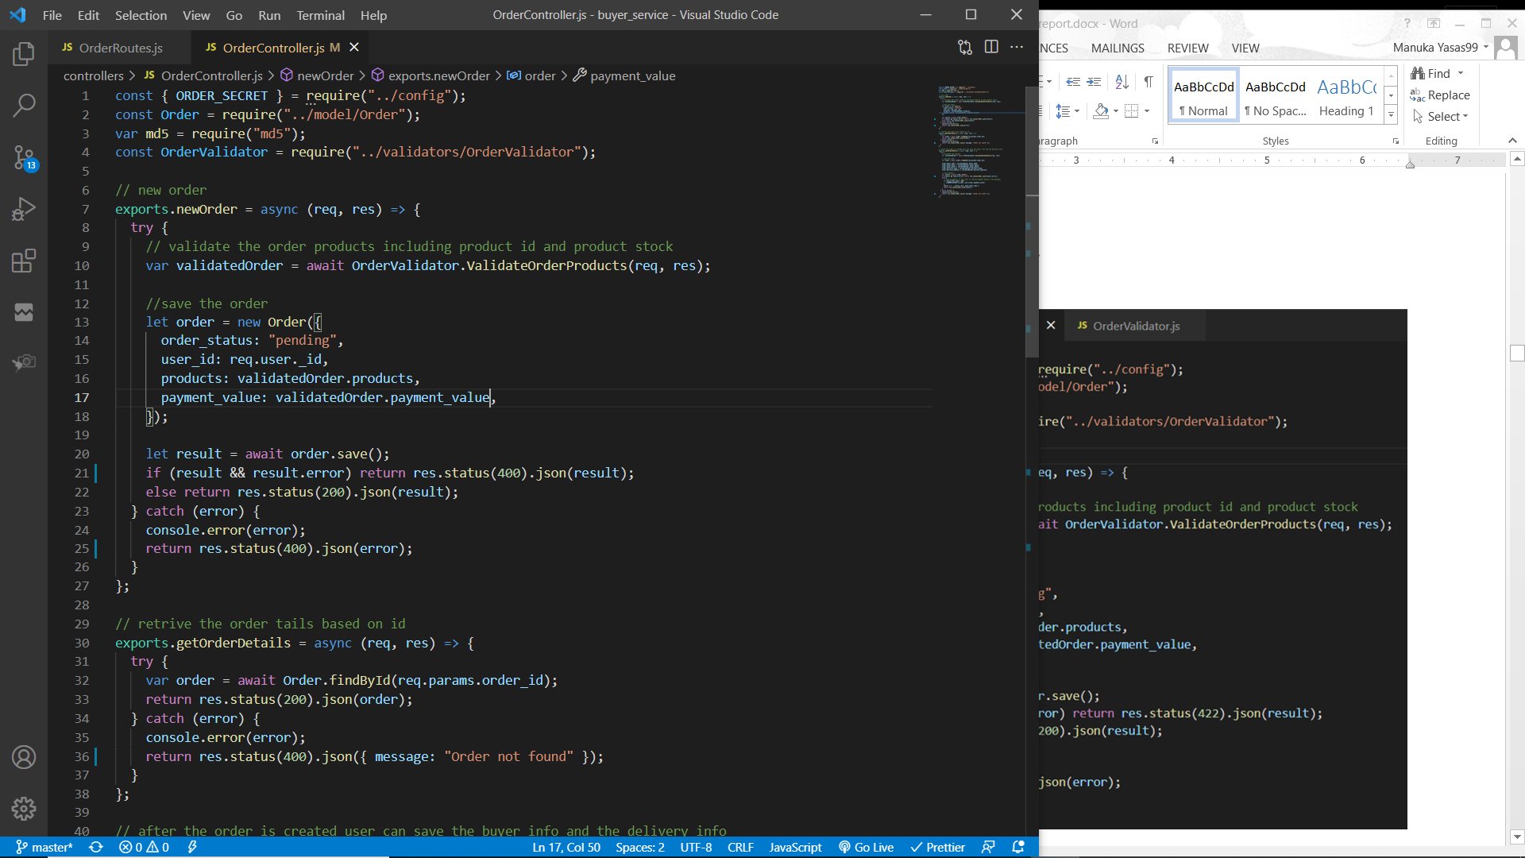

Validator function to validate request body such as valid products, products have stock (validateOrderProducts)





The initial POST request will be sent to the buyer service through ESB. (WSO2 EI). To create a new order, user must be authenticated. Therefore the “userAuth” middleware is used to filter the authenticated users/ requests. Request body must have an array of objects where each object must have the product id and its quantity. This request is validated using the above “validateOrderProducts” function. This function will iterate the array of objects and check if each object has a product id and then it checks if there is an existing product in the database with the product id in the object. Additionally, it validates that the product has enough stock to supply. If any of the validations fail, respective error messages will be sent back to the client through ESB. Else, an object with the validated products array and total payment value (product price * quantity) will be returned.

A new order will be created by setting the user’s id, products and payment value fields. The order status will be set to “pending”. This order object is saved and if it fails to save an error message is sent back to the client through ESB. Else, the saved object will be returned back to the client through ESB which will be required to save the delivery details and payment.

### Process of Saving / Updating buyer details and delivery in order

Workflow diagram

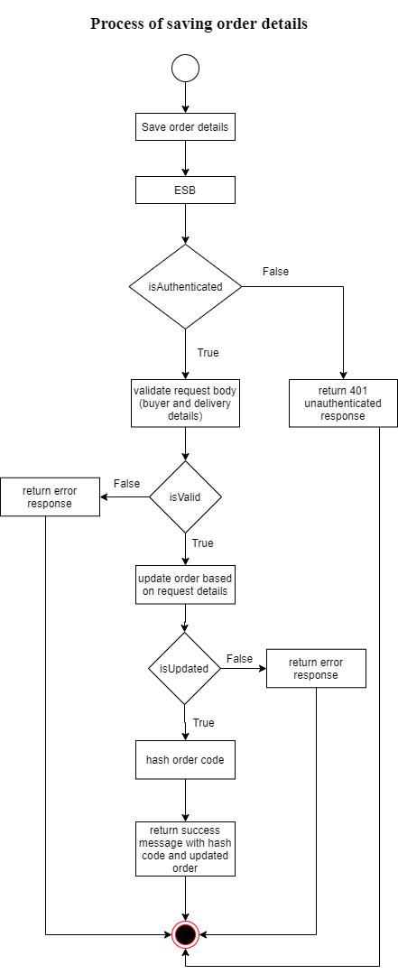

Service function

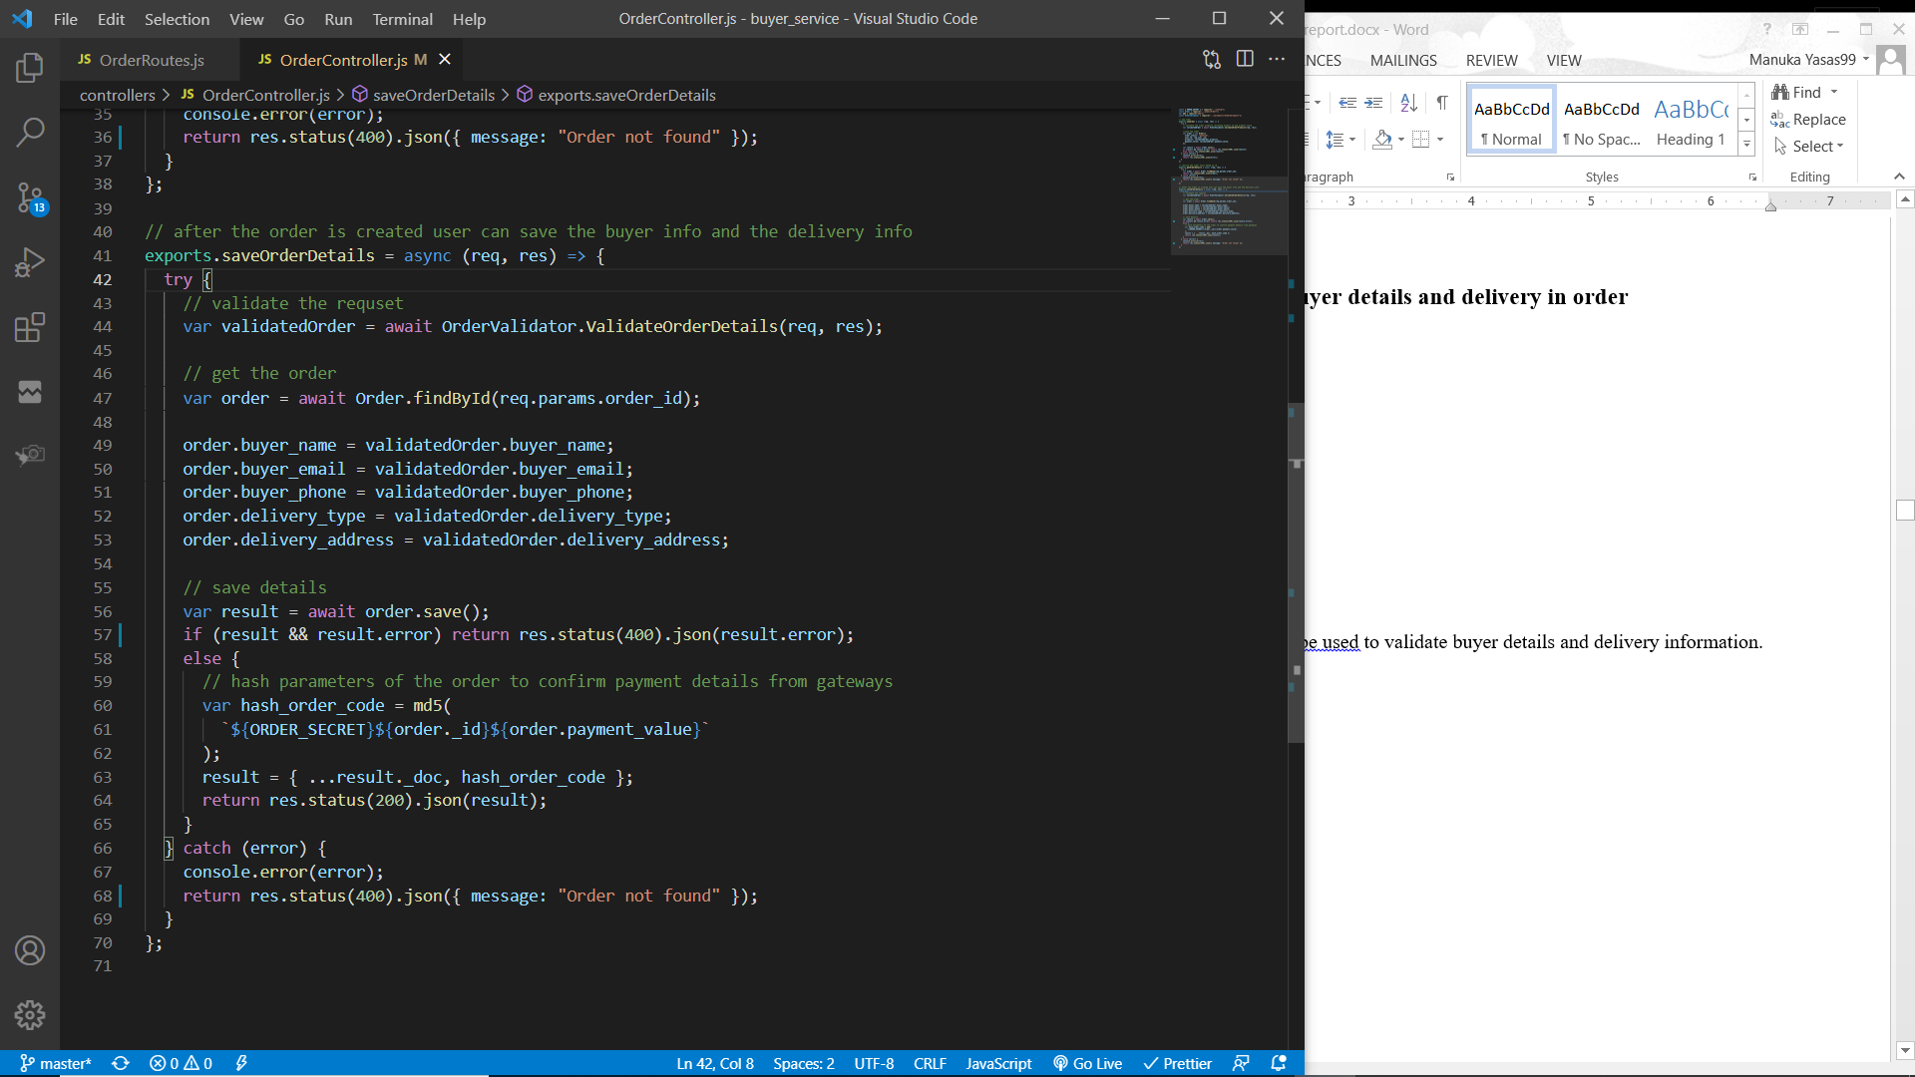

Function “ValidateOrderDetails” will be used to validate buyer details and delivery information.

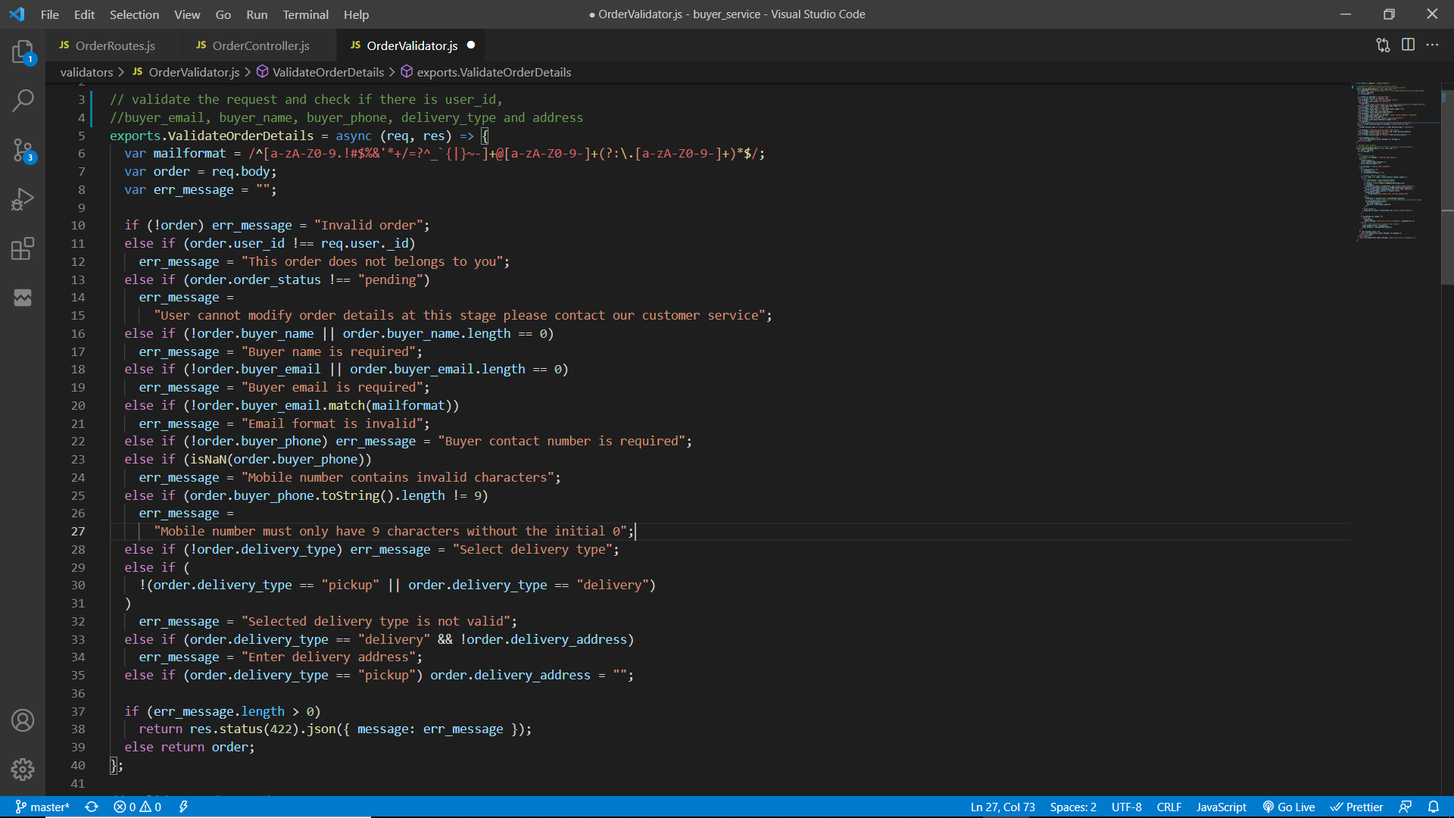

The initial POST request will be sent to the main application server through ESB. (WSO2 EI). To save / update the order, user must be authenticated. Therefore the “userAuth” middleware is used to filter the authenticated users/ requests. Request body must have the order id, buyer information such as buyer name, contact number and email; also, it must contain the delivery type mentioned. If the order needs to be delivered then delivery address field must not be empty. Delivery type can only be one of pick up or delivery. Mobile number must be a valid nine digit (Integer) number and the user email must be a valid email. All the above are validated using the function “ValidateOrderDetails” and if errors are found then respective error messages will be sent back to the client through ESB. Else, the validate request body will be returned.

Order object will be retrieved using the order id. If any error is occurred, an error message will be sent back to the client with status code 422 through the ESB.

The order object will be updated using the validated order information and saved to the database.

If it fails to update an error message will be sent back to the client.

After successfully saving the order, user can make the payment. To make the payment user can make it through credit debit card, mobile service provider or through cash on delivery. If the user select credit card payment or mobile payment, user will navigate to the respective payment gateway to make the payment. Payment gateways will accept the order id, transfer amount along with the credentials it require.

To provide extra security when validating the order id and transfer by the payment gateways, an md5 encrypted string with the order secret (environment variable), order id and transfer amount will be sent. This hashed payment code is generated and the updated order object is sent to the client through ESB.

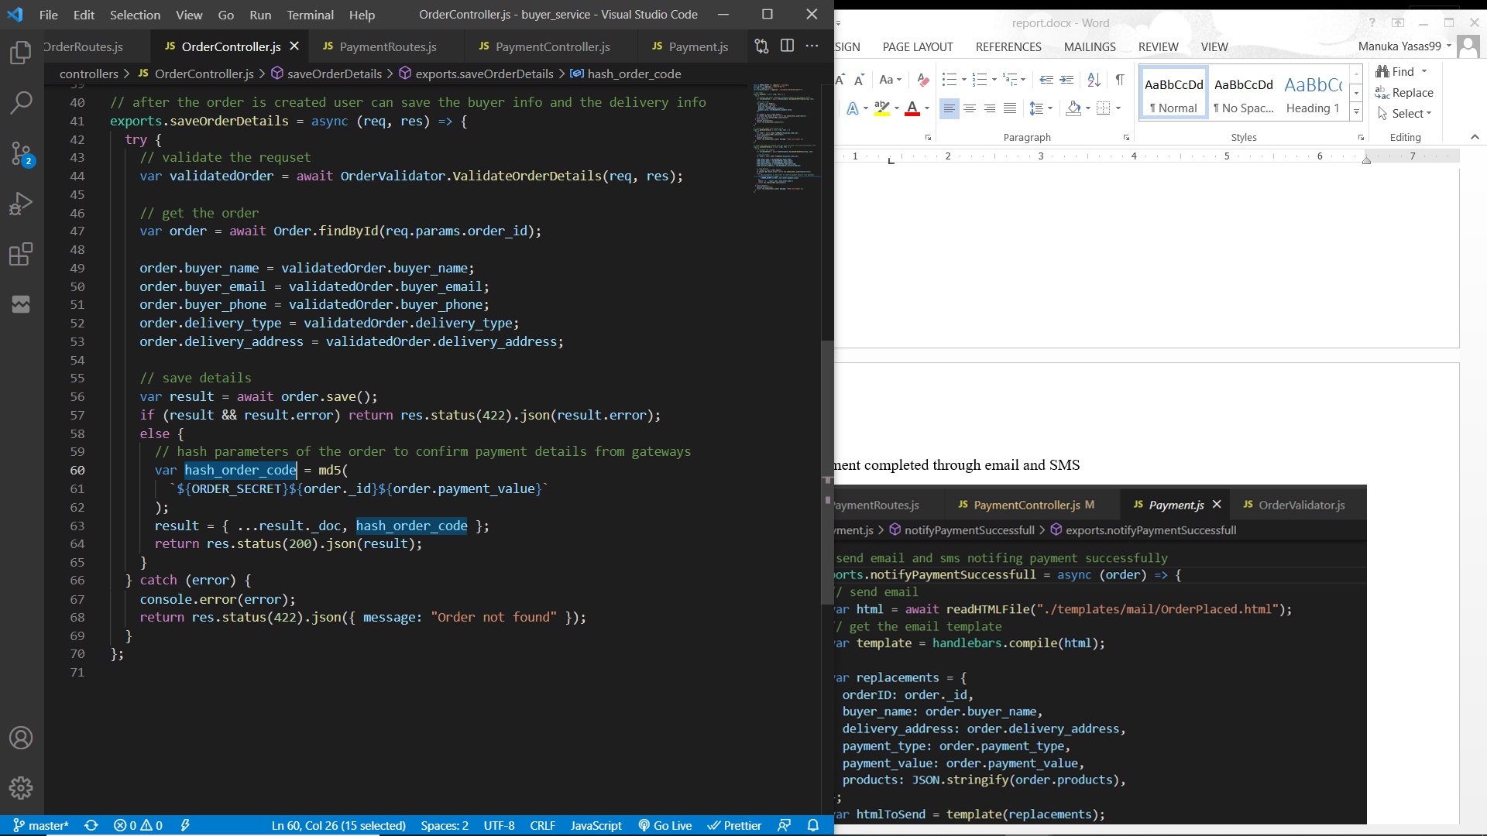

### Process of retrieving order details

Service function

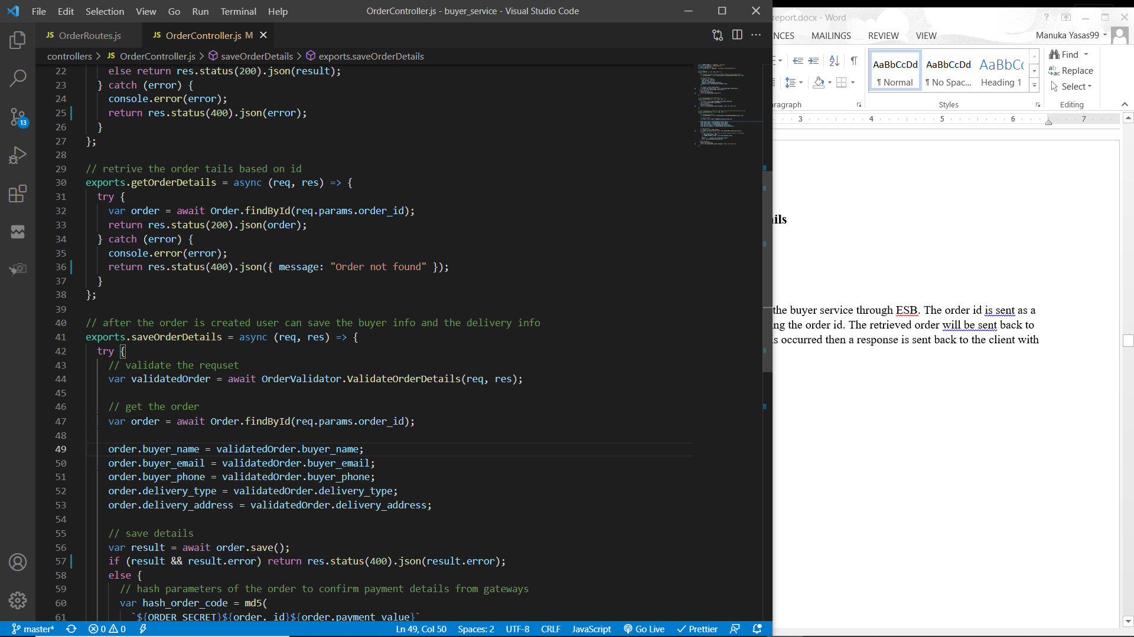

The initial GET request will be sent to the buyer service through ESB. The order id is sent as a parameter and the order is retrieved using the order id. The retrieved order will be sent back to the client through the ESB. If an error is occurred then a response is sent back to the client with 422 status code.

## Processing payments

To process payments request must have a parameter with the payment type. Based on this parameter user will be route to the required service. There are three payment types, cash on delivery, credit card payment and mobile payment.

If the payment type parameter is “COD”, the ESB will route the request to the buyer service to process the cash on delivery payment.

If the payment type parameter is “bank”, the ESB will route the request to the credit card payment gateway service to process the payment.

If the payment type parameter is “mobile”, the ESB will route the request to the mobile payment gateway service to process the payment.

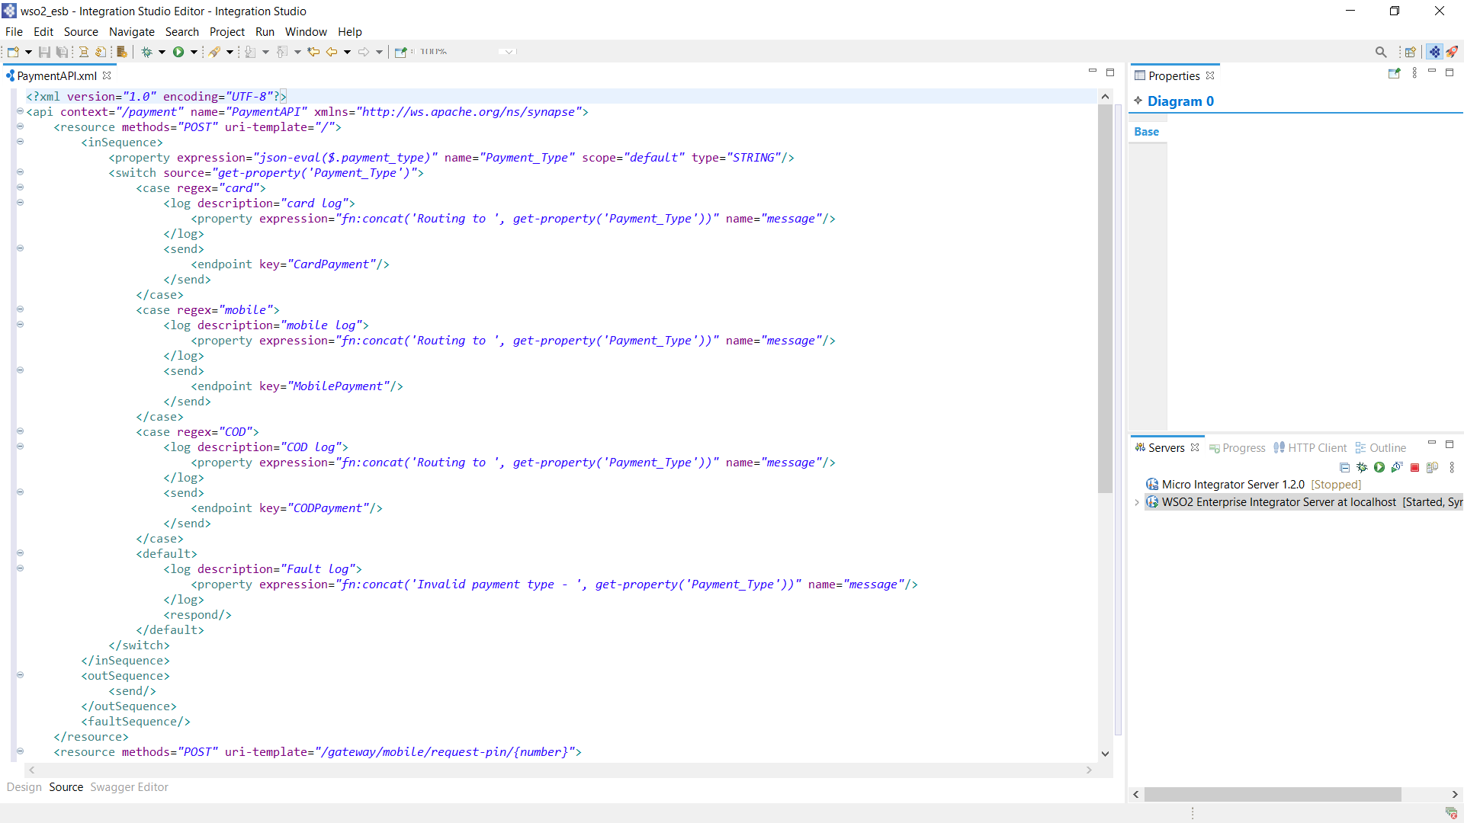

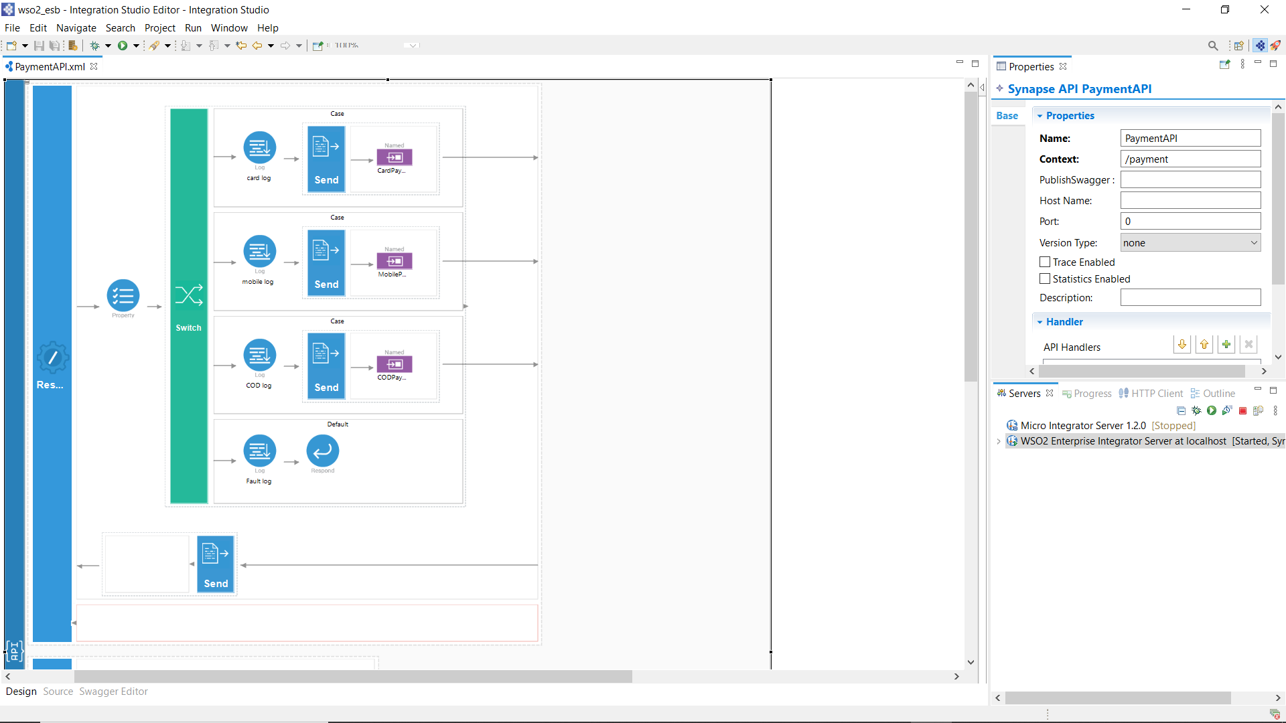

### Process of payment through credit card

Service interface

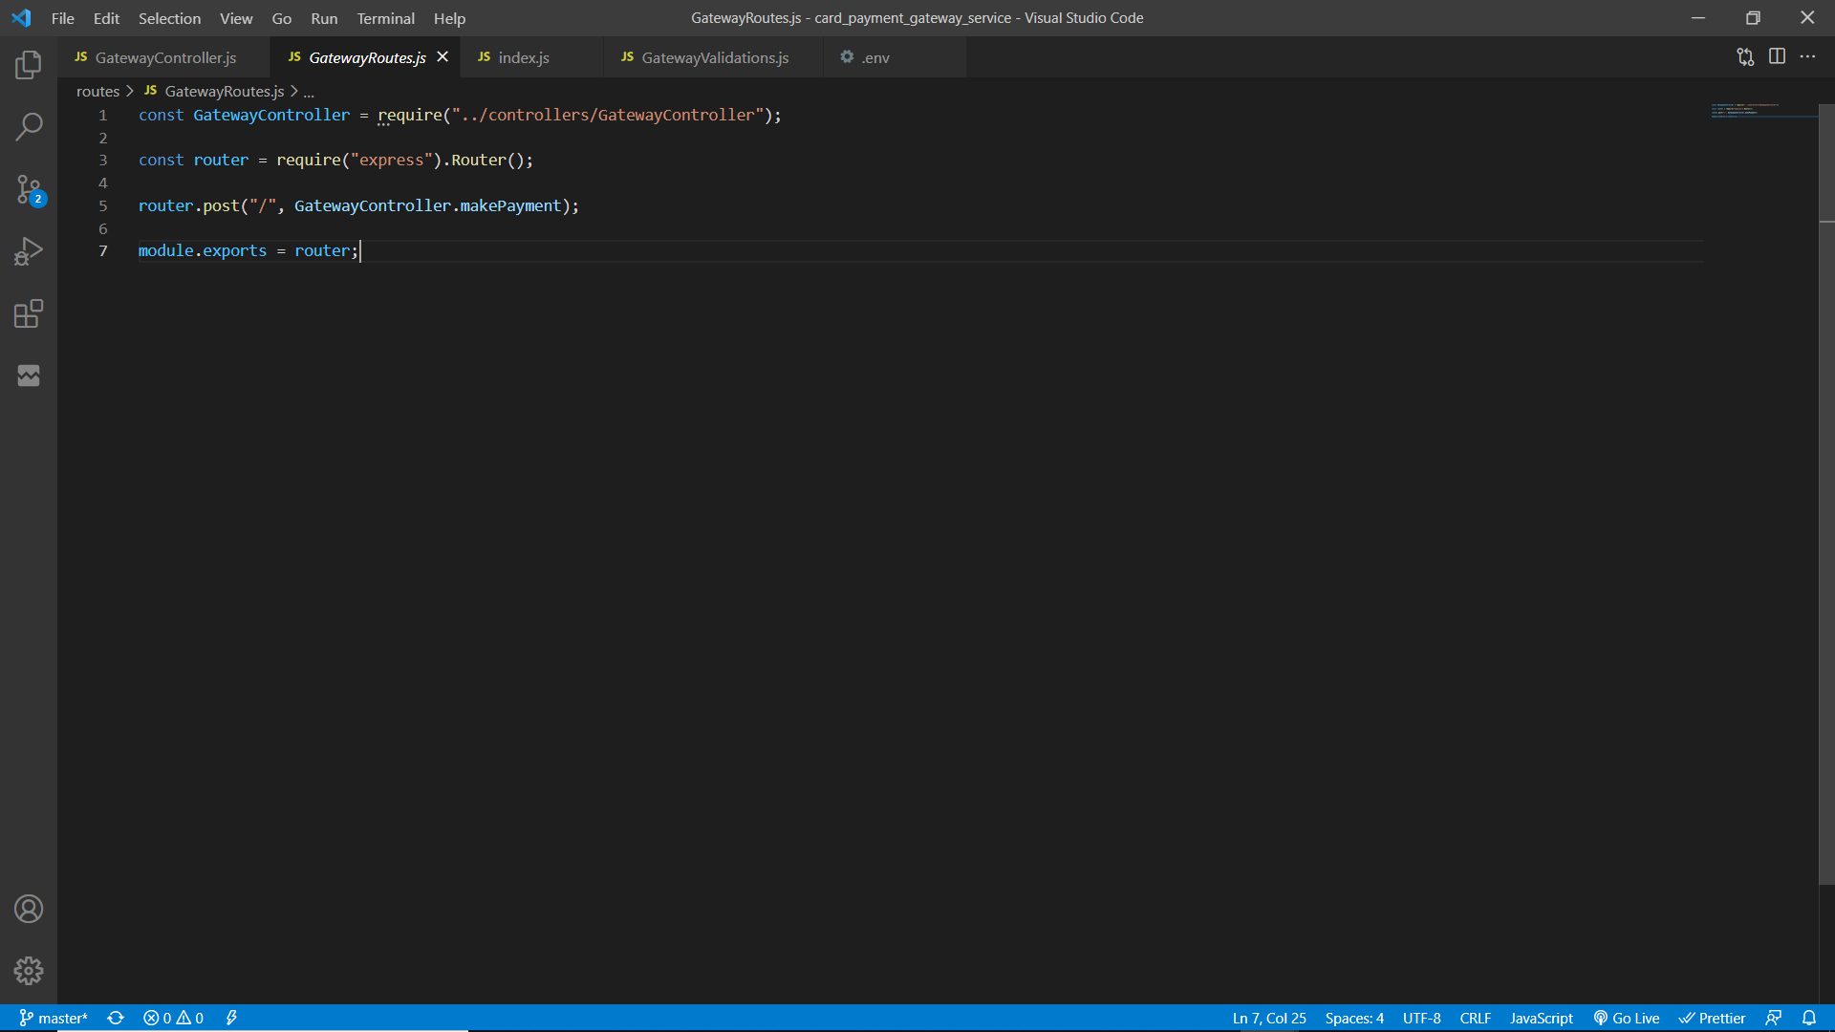

Service function

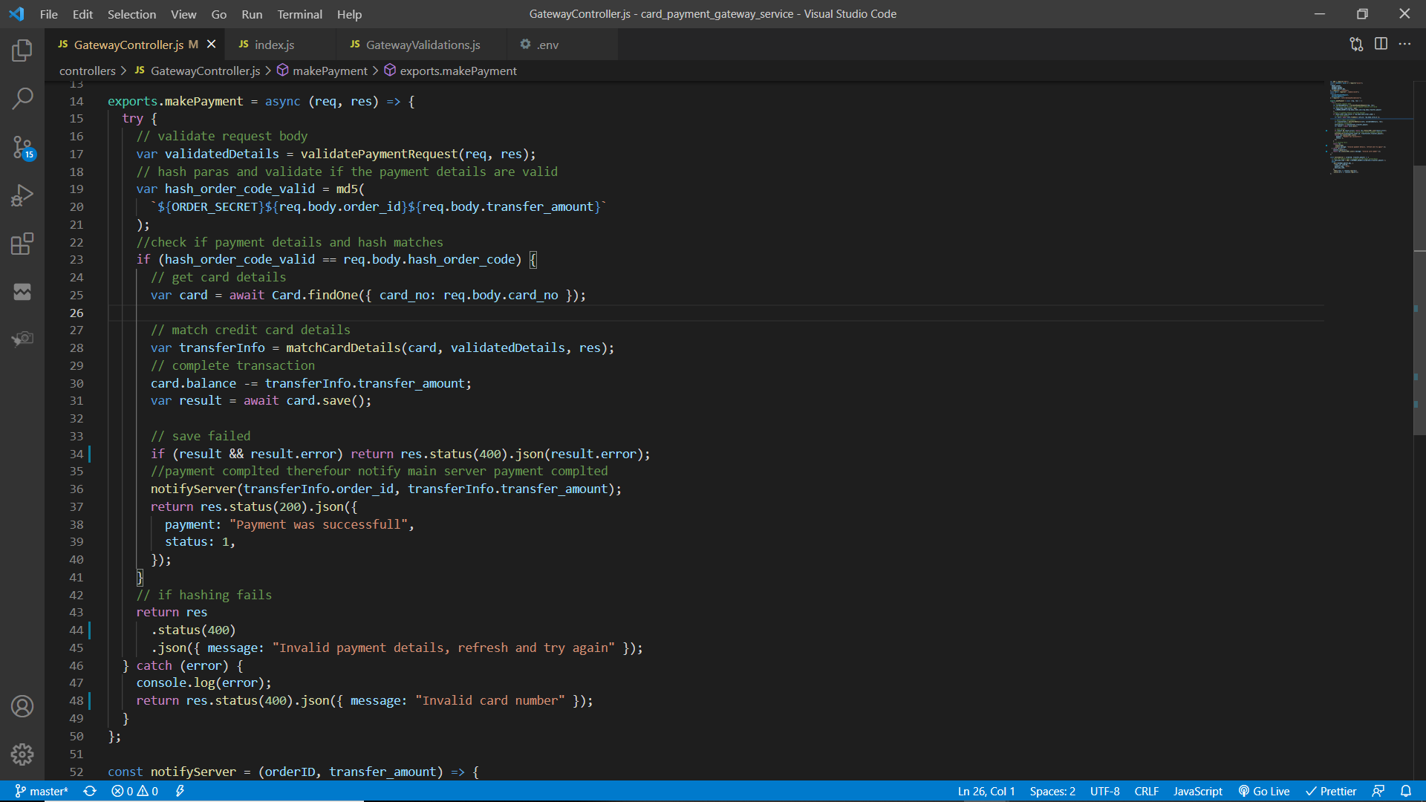

The initial POST request will be sent to the credit card payment gateway service through ESB if the request has a parameter “payment_type” with its value “card”. The request body will be validated by the “validatePaymentRequest” method to check if it has order id, order hash code, transfer amount, credit card number, CVC number and a card holder name.

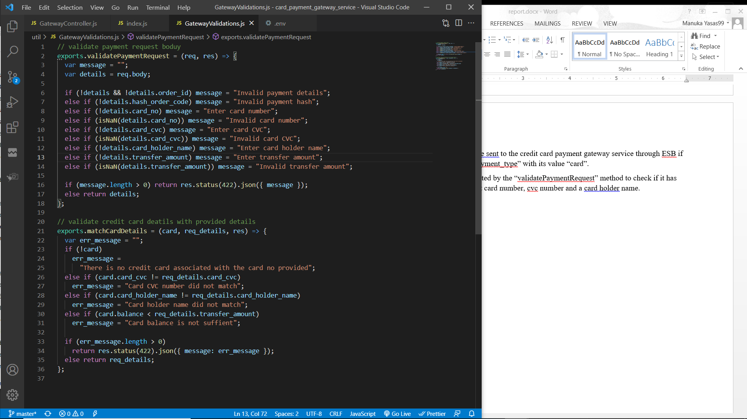

If the validation fail an error response with the respective message will be sent back to the client via ESB. Else, the order hash will be validated. To validate the hash sent from the request, a new hash will be created by using the order secret string constant along with the order id and transfer amount.

If the newly created hash string does not match with the hash code sent by the request that means the payment details does not match with the order details therefore an error response will be sent back to the client.

If hash matches credit card object will be retrieved from the database based on the credit card number. If there is no credit card object then an error response will be sent back. Else then the credit card details will be validated.

To validate credit card details “matchCardDetails” function will be used. Credit card number, CVC number and the card holder name must be matched with the request data and also the remaining balance of the account must be greater than the transfer amount.

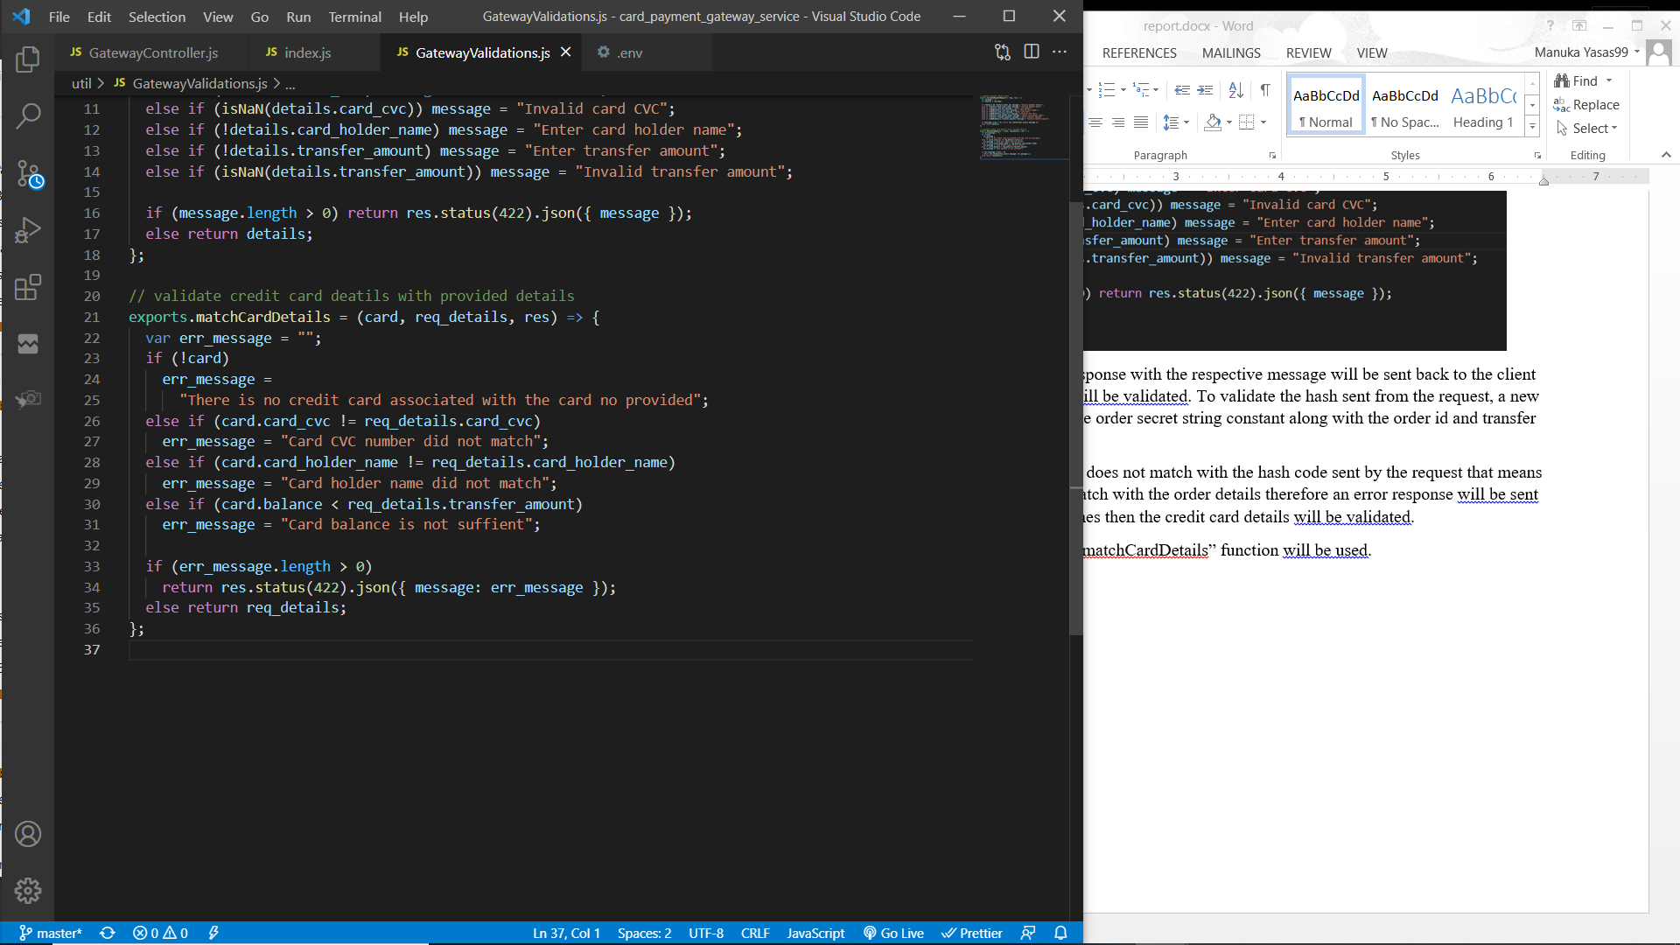

If the validation fail an error response with the respective message will be sent back to the client via ESB. Else the transaction will be made updating the credit card balance. If the transaction failed then an error response will be sent back. Else a success message will be sent back via ESB and the buyer service will be notified that the order was completed.

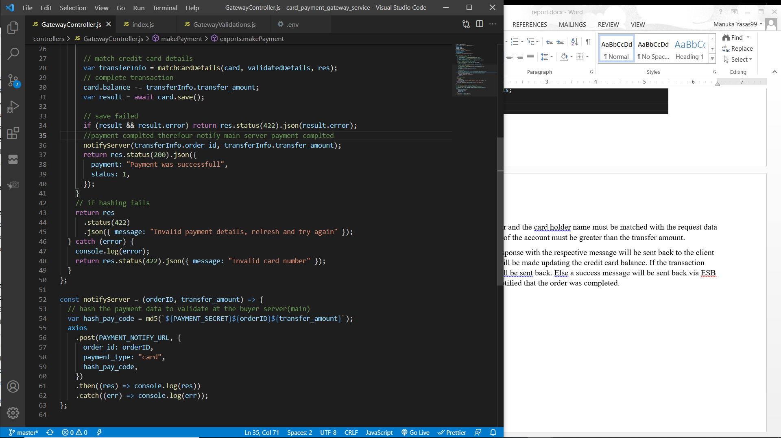

Notify server method will send a POST request to the buyer service with data such as order id, transfer amount and payment hash code. Payment hash code is generated using payment secret (string constant in the environment configuration), order id and the transfer amount. This hash code is useful to validate that the payment was completed through the payment gateway.

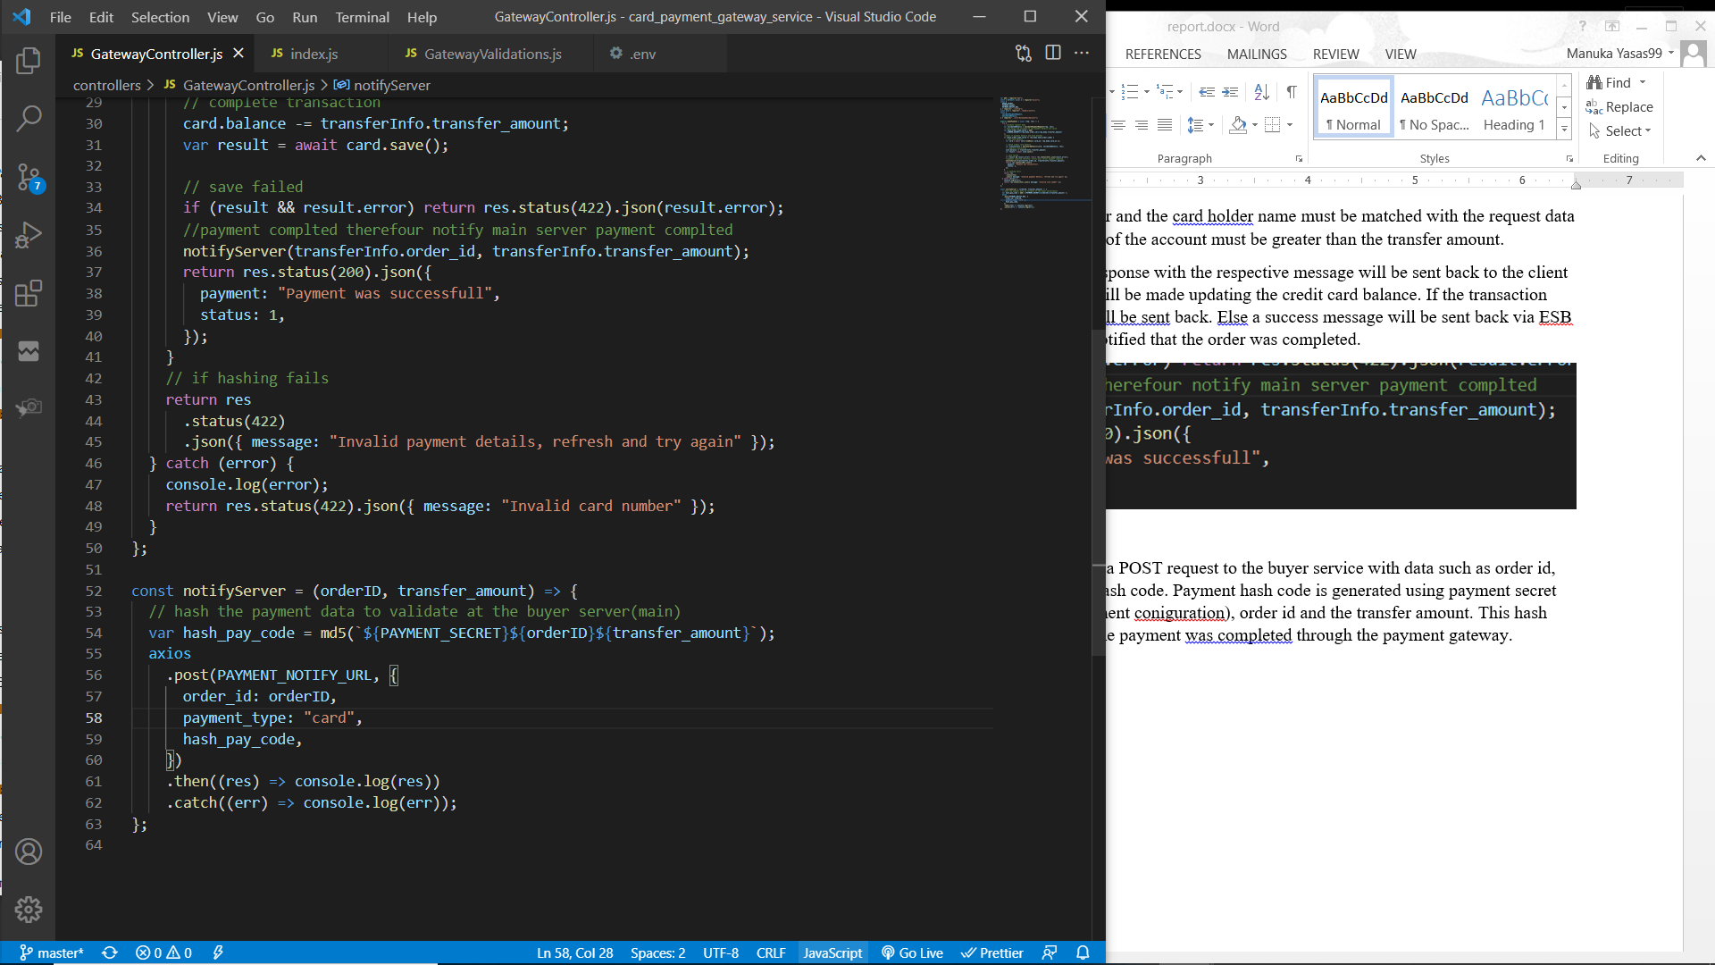

### Process of payment through mobile payment gateway

Service interface

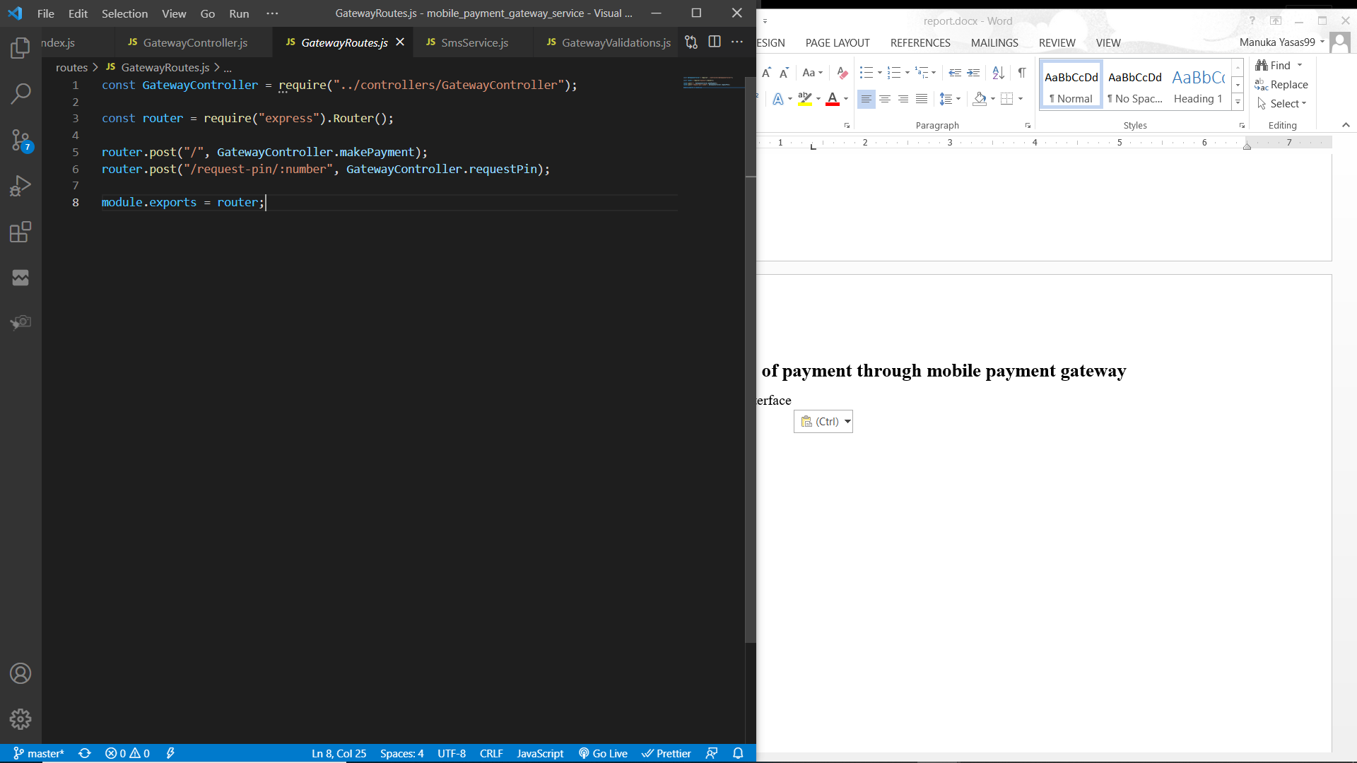

Service function

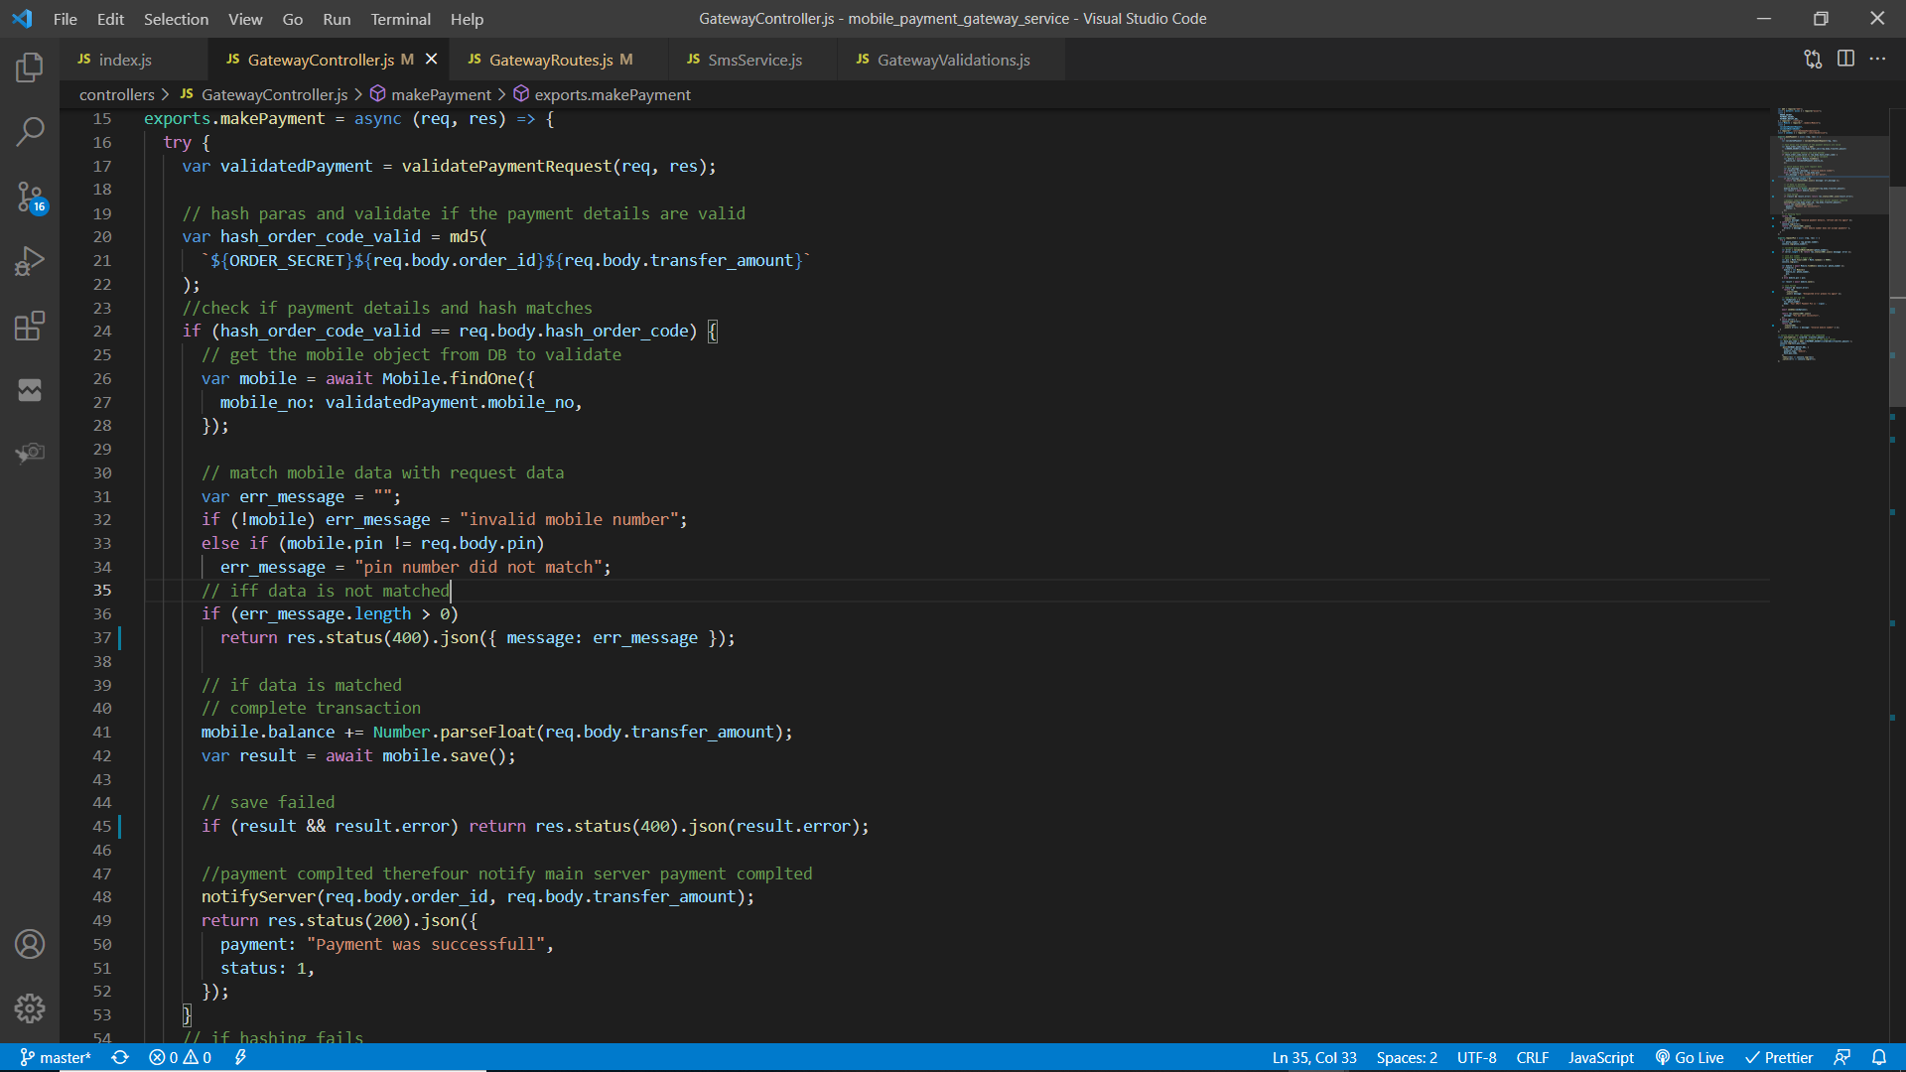

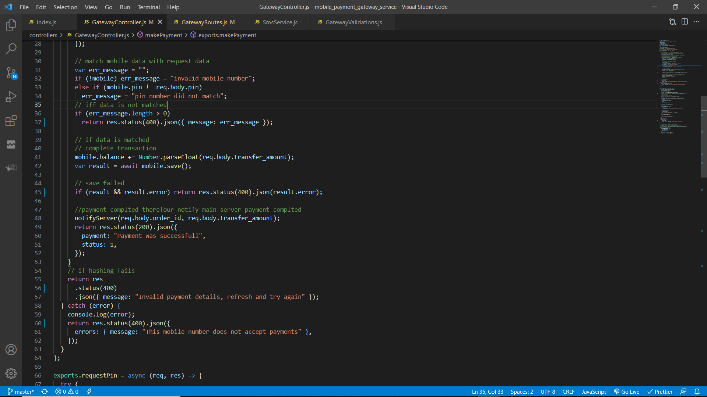

The initial POST request will be sent to the mobile payment gateway service through ESB if the request has a parameter “payment_type” with its value “mobile”. The request body will be validated by the “validatePaymentRequest” method to check if it has order id, order hash code, transfer amount, mobile number and mobile pin number.

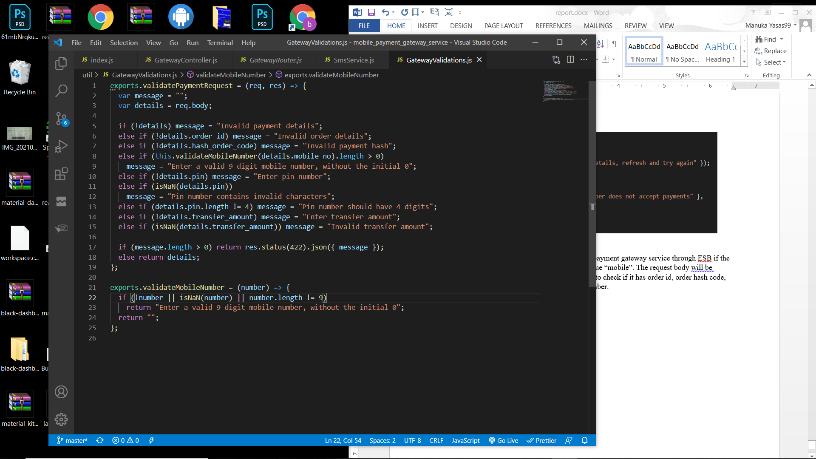

If the validation fail an error response with the respective message will be sent back to the client via ESB. Else, the order hash will be validated. To validate the hash sent from the request, a new hash will be created by using the order secret string constant along with the order id and transfer amount. If the newly created hash string does not match with the hash code sent by the request that means the payment details does not match with the order details therefore an error response will be sent back to the client. If hash matches then the mobile payment details will be validated.

To validate the mobile payment, mobile object will be retrieved from the database based on the mobile number. If the mobile object does not exist then an error response will be sent. Else, mobile pin will be validated. If the validation fails then an error response will be sent back. Else, the mobile balance will be updated (transfer amount will be added) and saved. If the payment fail then an error response will be sent back. Else, a success message will be sent back via ESB and the buyer service will be notified that the order was completed.



Notify server method will send a POST request to the buyer service with data such as order id, transfer amount and payment hash code. Payment hash code is generated using payment secret (string constant in the environment configuration), order id and the transfer amount. This hash code is useful to validate that the payment was completed through the payment gateway.



### Process of requesting mobile pin number

Service interface



Service function

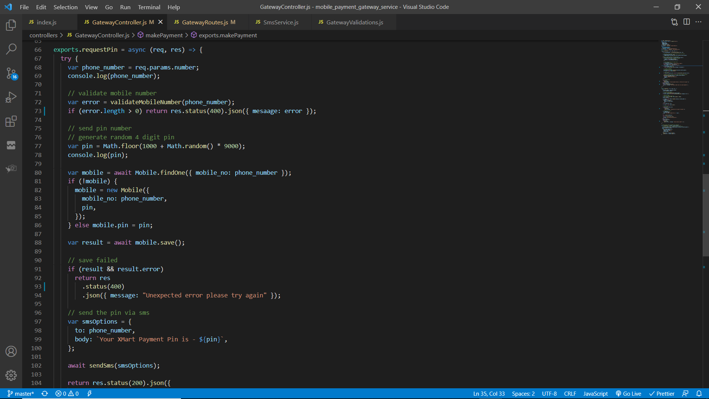

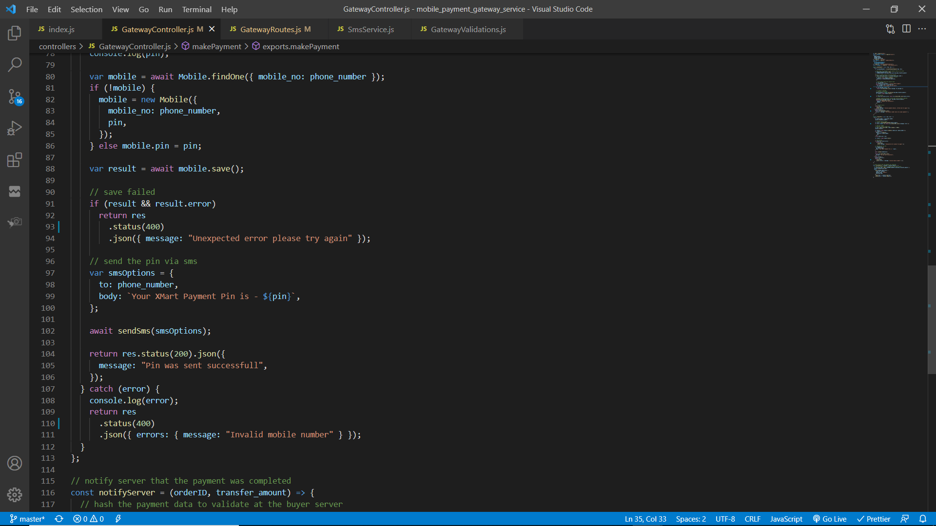

The initial POST request will be sent to the mobile payment service through ESB. The mobile number is sent as a parameter. Mobile number will be validated from the below function and if any errors were found an error response will be sent back.

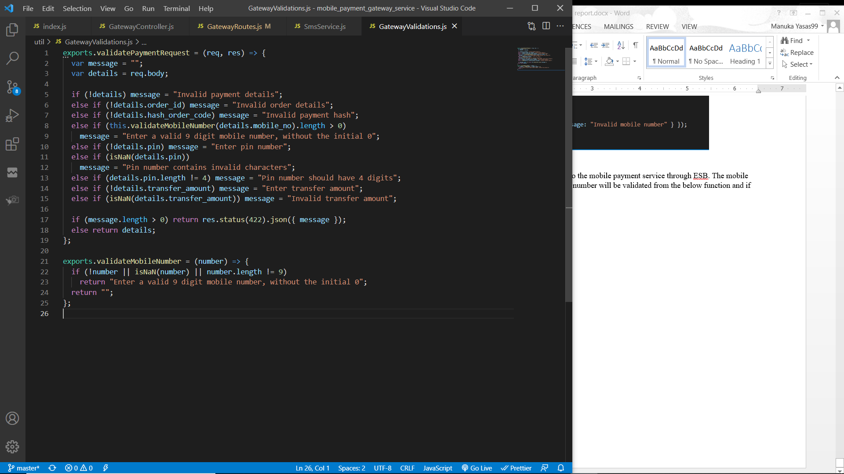

After the validation was completed successfully then a four digit pin number will be created.

The mobile object will be retrieved based on the mobile number from the database and the pin number will be updated and saved. If there is no object in the database then a new mobile object will be created and the pin number will be saved.

If an error is caught while saving an error response will be sent back to the client through the ESB. Else, a success message will be sent back and a SMS will be sent to the number with the pin number. SMS will be sent using Twilio.

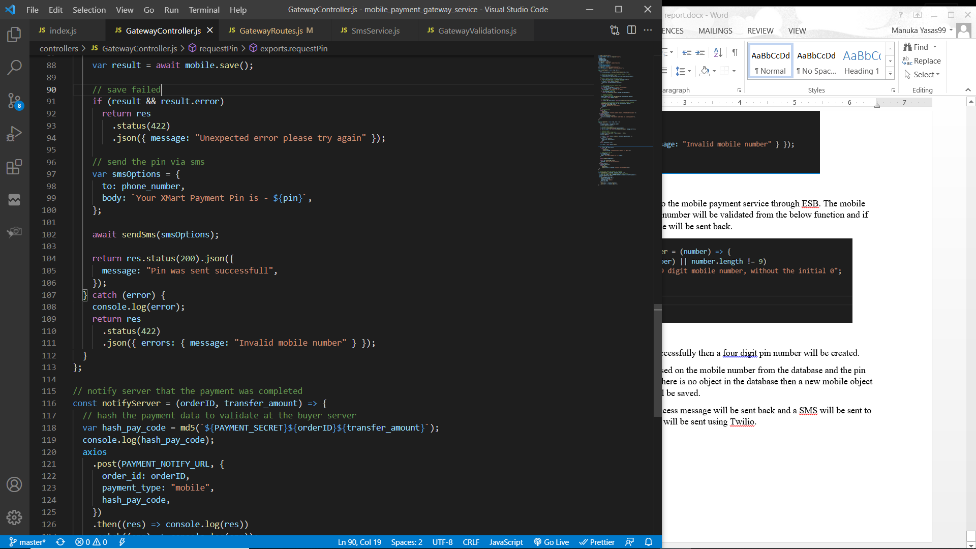

SMS service

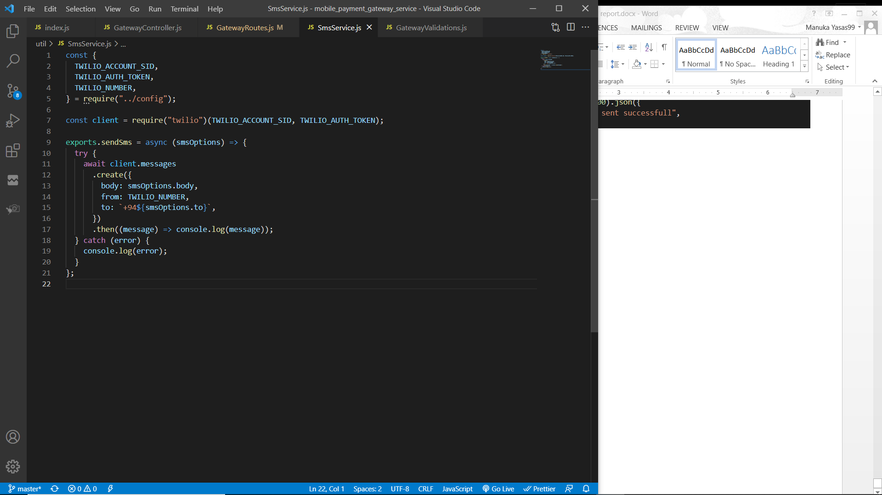

### Process of listening to payment notifications

Service interface

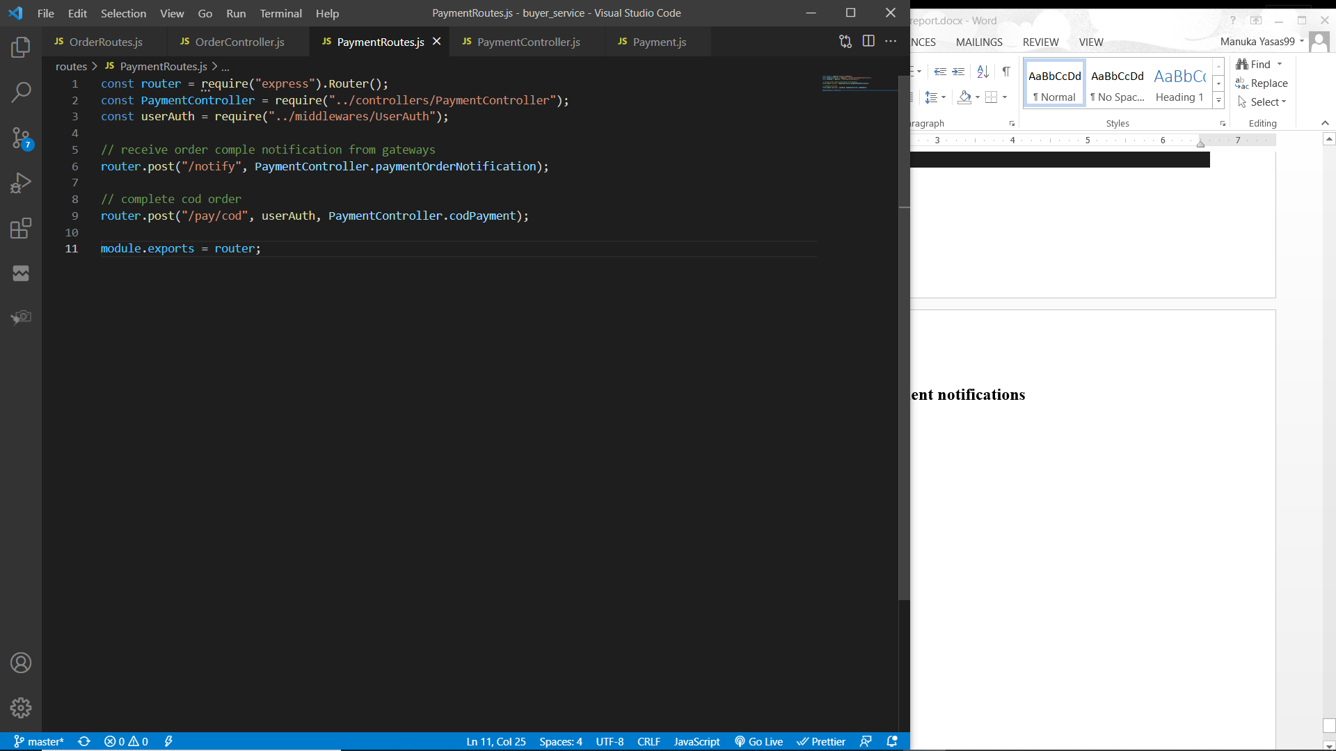

Service function

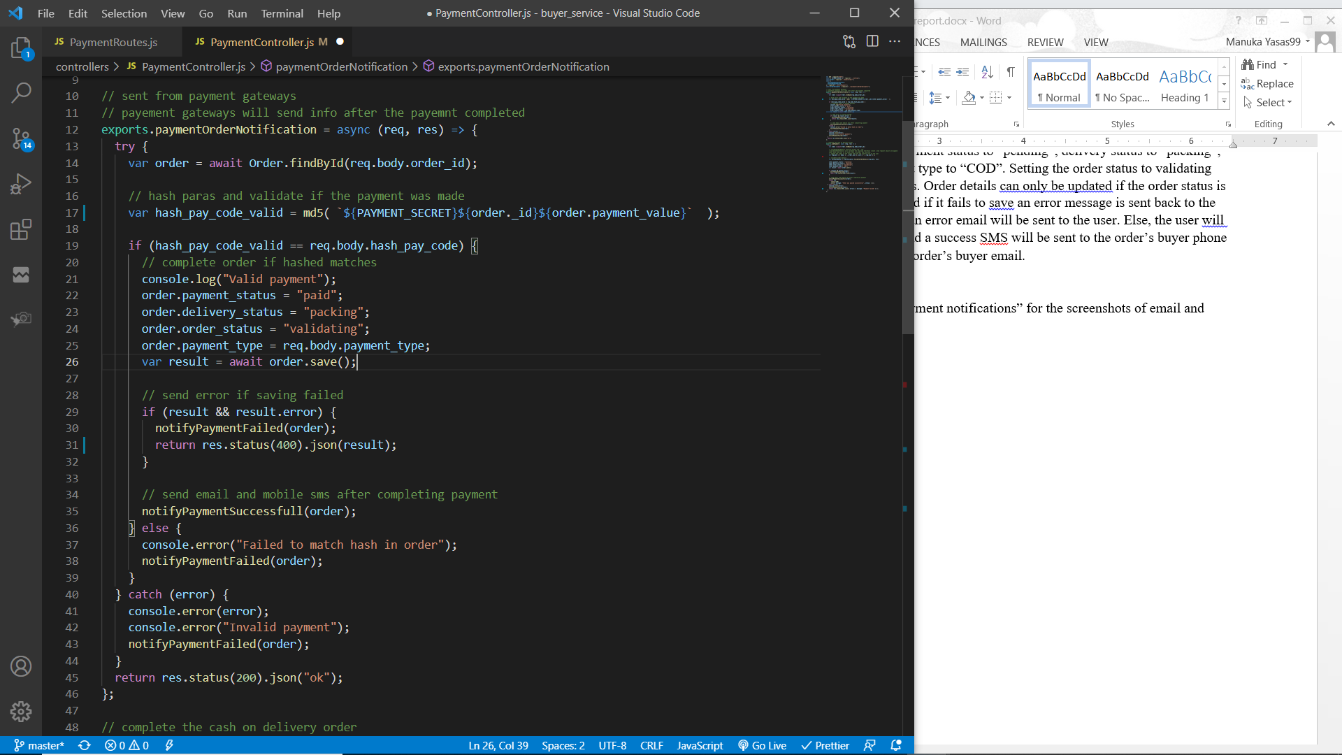

After completing the payment by payment gateways (credit card / mobile ) it will notify the buyer service. A POST request will be sent through the ESB to the buyer service with order id, transfer amount and the payment hash. Order will be retrieved from the order id and if there is an order then the payment hash needs to be validated.

To validate the payment hash, a new md5 hash will be created from the payment secret (Environment variable), order id and order payment value. Then if the payment hash from the request and the newly created hash from the order object matches, the payment is validated.

If the payment was not validated, “notifyPaymentFailed” method will be called and an unsuccessful email and SMS will be sent based on the order buyer information. Else, “notifyPaymentSuccessful” method will be called and a successful email and SMS will be sent based on the order buyer information.

SMS service through TWILIO

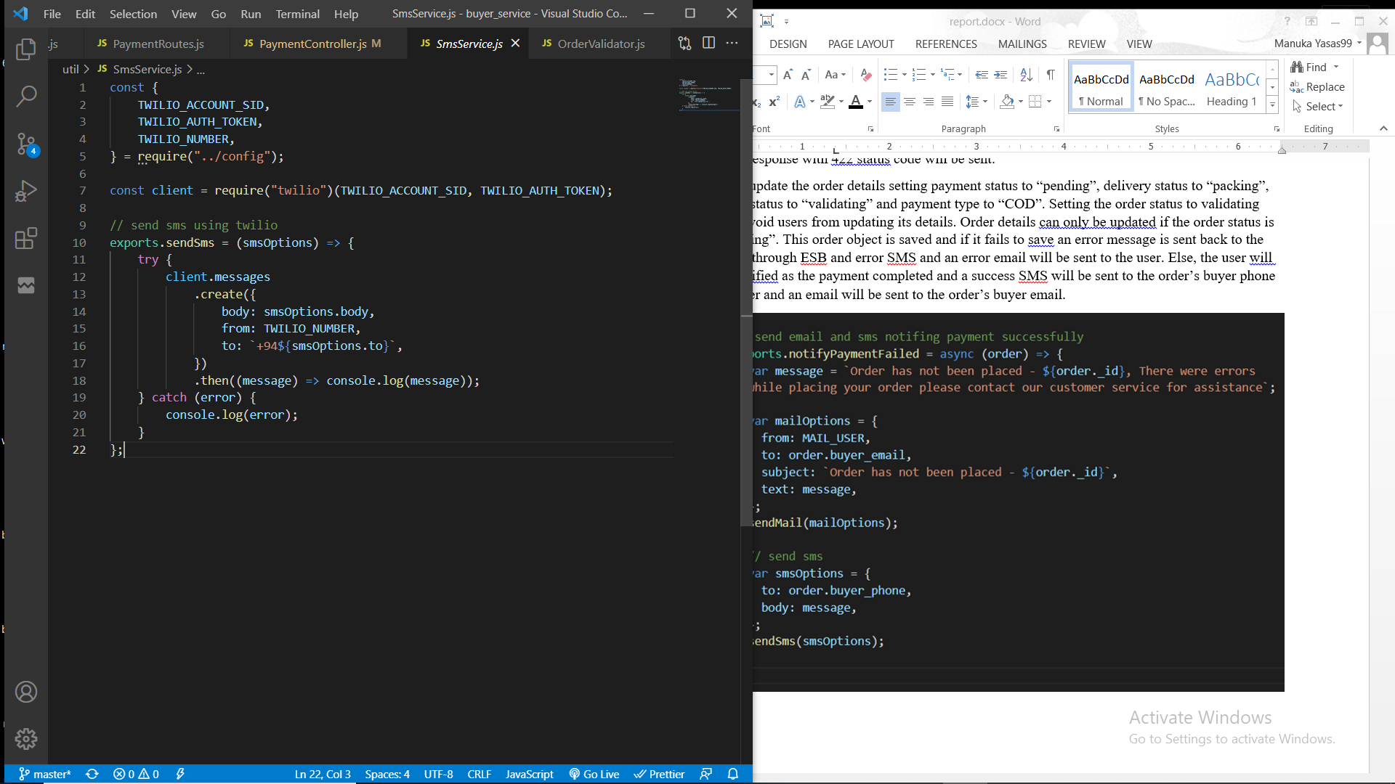

Mail service through Gmail

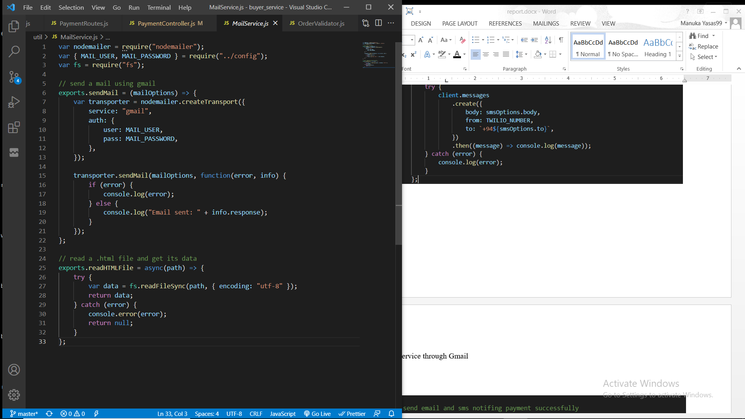

Notify payment completed through email and SMS

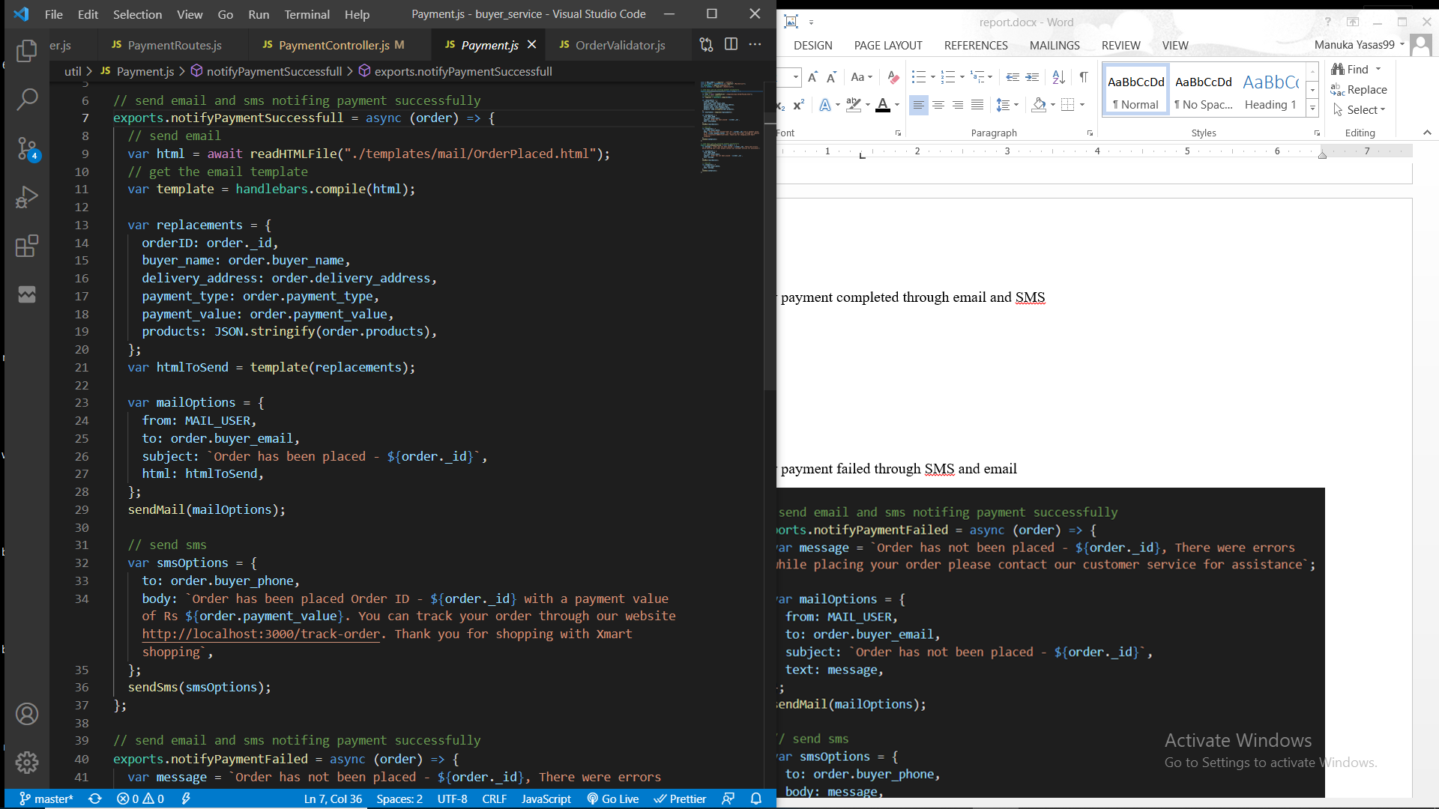

**Email template with data sent through Gmail**

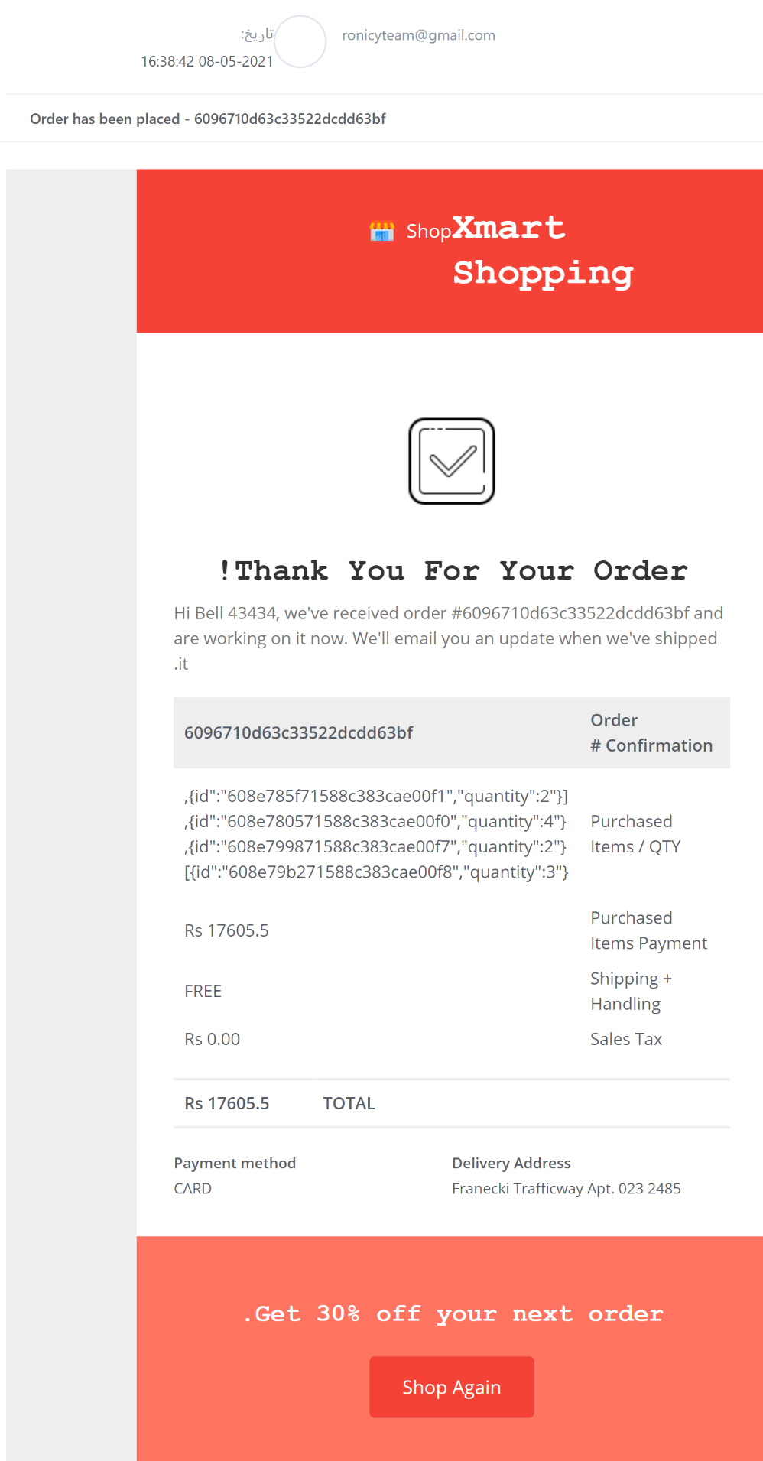

**SMS sent through Twilio**

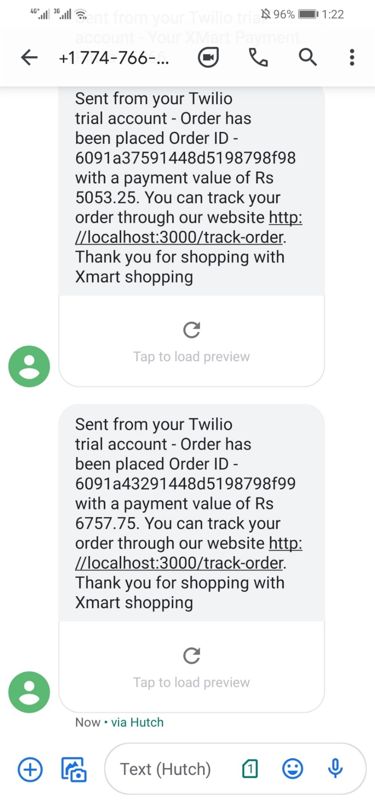

Notify payment failed through SMS and email

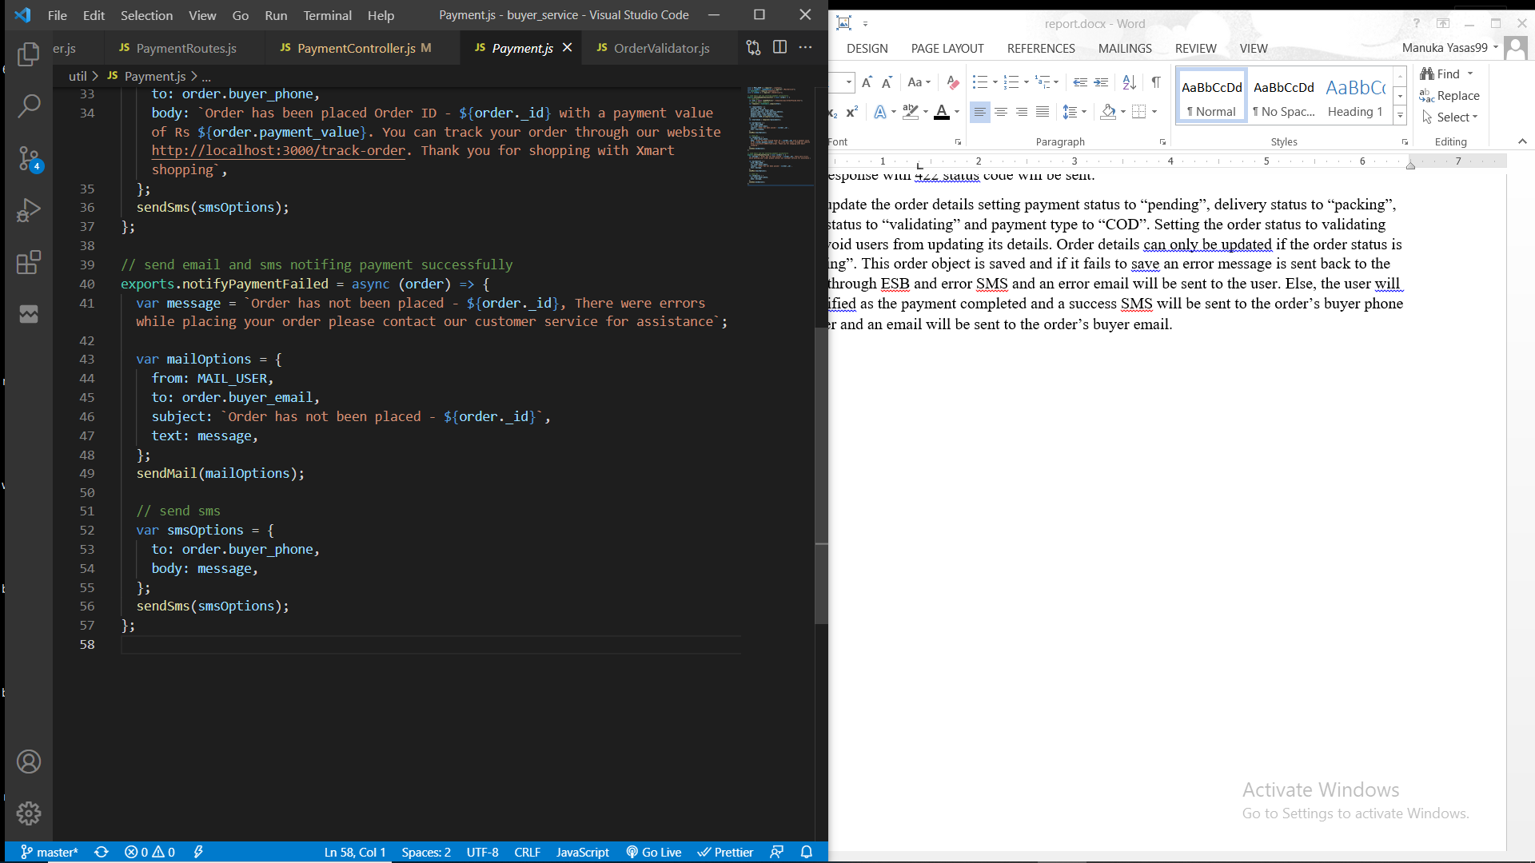

### Process of placing cash on delivery order.

Service function

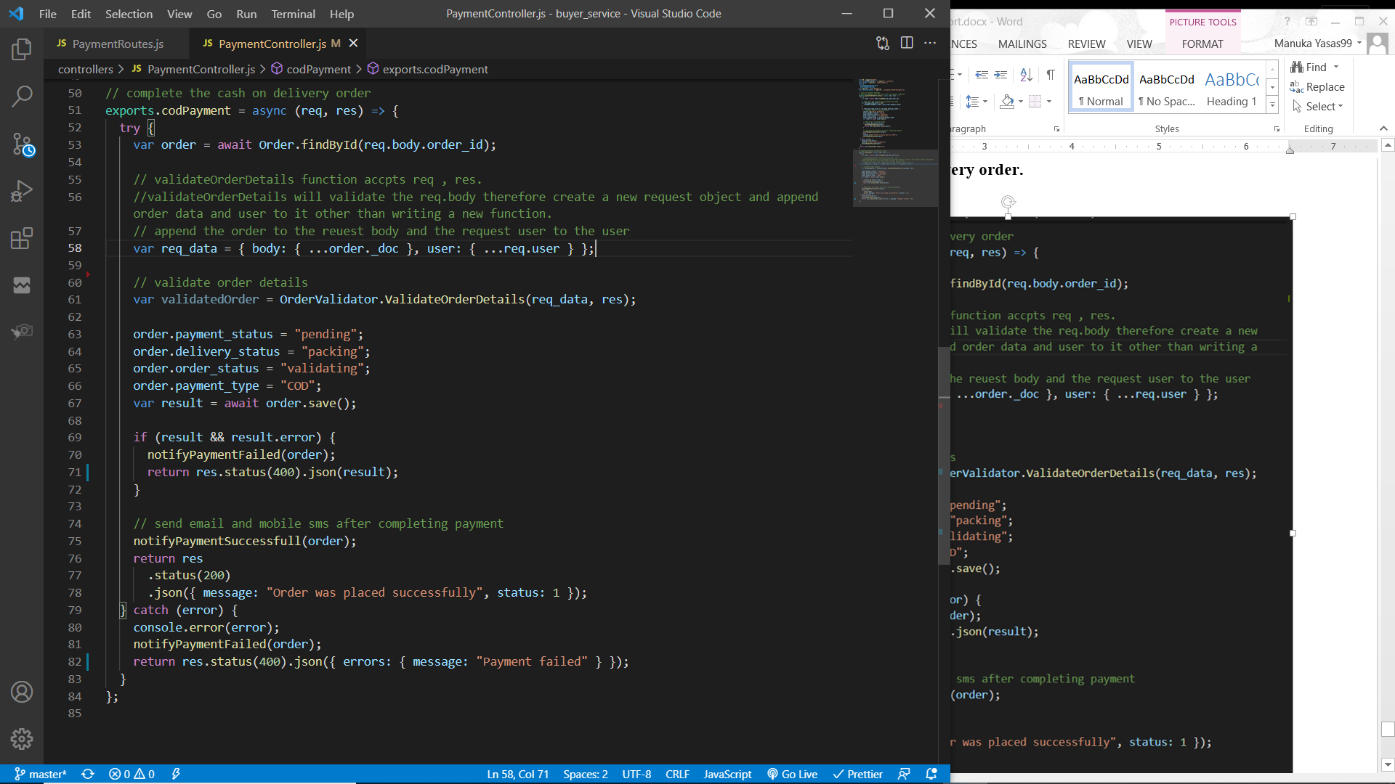

The initial POST request will be sent to the buyer service through ESB if the request has a parameter “payment_type” with its value “COD”. The request is required to send the order ID. Then the order object will be retrieved. Order details including the buyer and delivery information must be validated before placing the order. As in above functions “ValidateOrderDetails” function is used to validate the request. If any errors are found then an error response with 422 status code will be sent.

Then update the order details setting payment status to “pending”, delivery status to “packing”, order status to “validating” and payment type to “COD”. Setting the order status to validating will avoid users from updating its details. Order details can only be updated if the order status is “pending”. This order object is saved and if it fails to save an error message is sent back to the client through ESB and error SMS and an error email will be sent to the user. Else, the user will be notified as the payment completed and a success SMS will be sent to the order’s buyer phone number and an email will be sent to the order’s buyer email.

(please refer “Process of listening to payment notifications” for the screenshots of email and SMS and the code)

# Authentication and Security Mechanism adopted with system

# Screenshots of the User Interfaces

# Appendix

## WSO2 Enterprise Integrator

### Authentication service

### Seller service

### Buyer service

### Credit card payment gateway service

### Mobile payment gateway service

### Delivery service

## Rest Services

### Authentication service

### Seller service

### Buyer service

### Credit card payment gateway service

### Mobile payment gateway service

### Delivery service